Data design management

Sumanpreet kaur

Reference number: 0353513

ER-Diagram

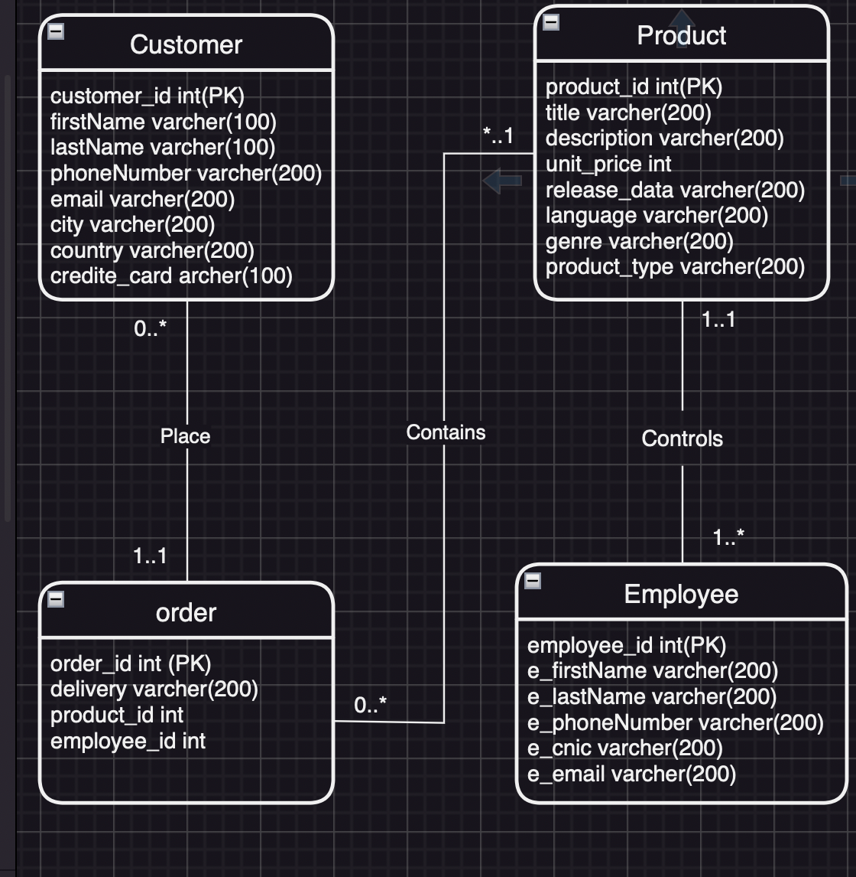

SQL script:

Create table Employee(
employee_id int PRIMARY KEY,
employee_firstNamevarchar(100),
employee_lastNamevarchar(100),
employee_phonevarchar(100),
employee_cnicvarchar(100)
)
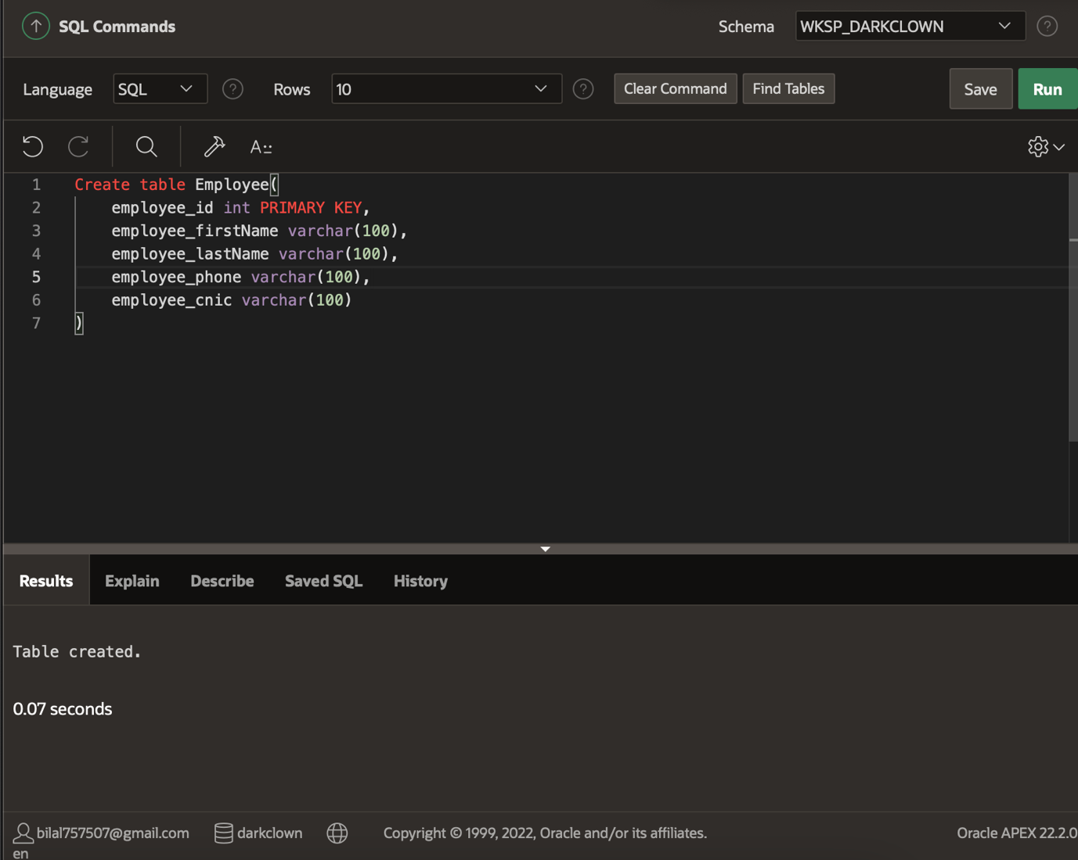

Create table Customer(
customer_id int PRIMARY KEY,
firstName varchar(100),
lastName varchar(100),
phoneNumber varchar(100),
email varchar(100),
country varchar(100),
credite_card varchar(100)
)
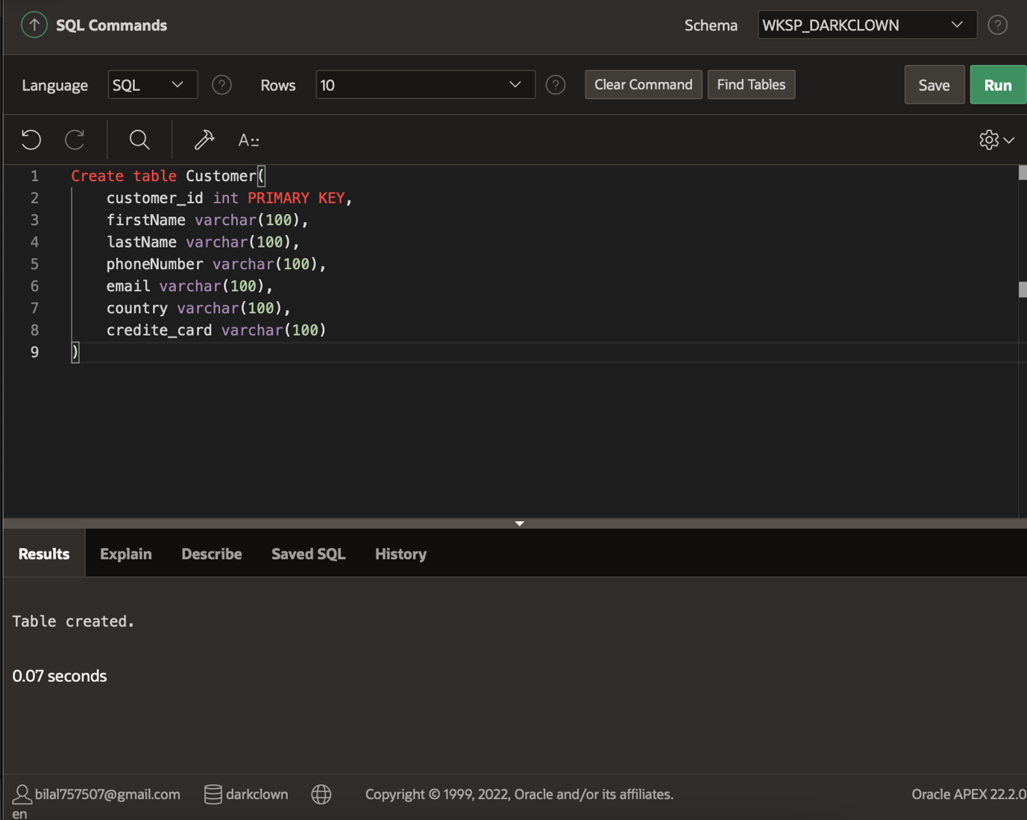
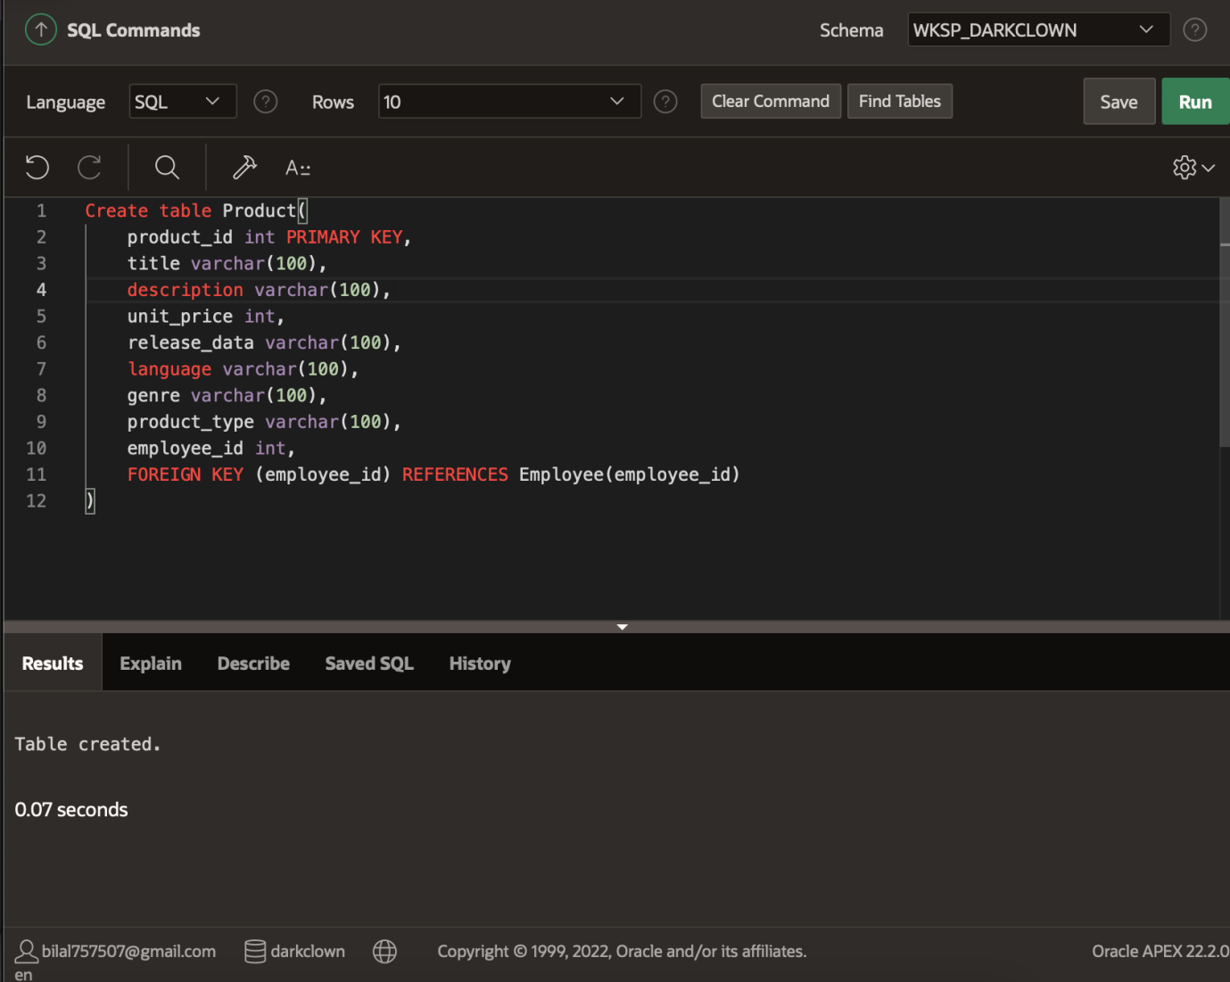

Create table Product(
product_id int PRIMARY KEY,
title varchar(100),
description varchar(100),
unit_price int,
release_data varchar(100),
language varchar(100),
genre varchar(100),
product_type varchar(100),
employee_id int,
FOREIGN KEY (employee_id) REFERENCES Employee(employee_id)
)

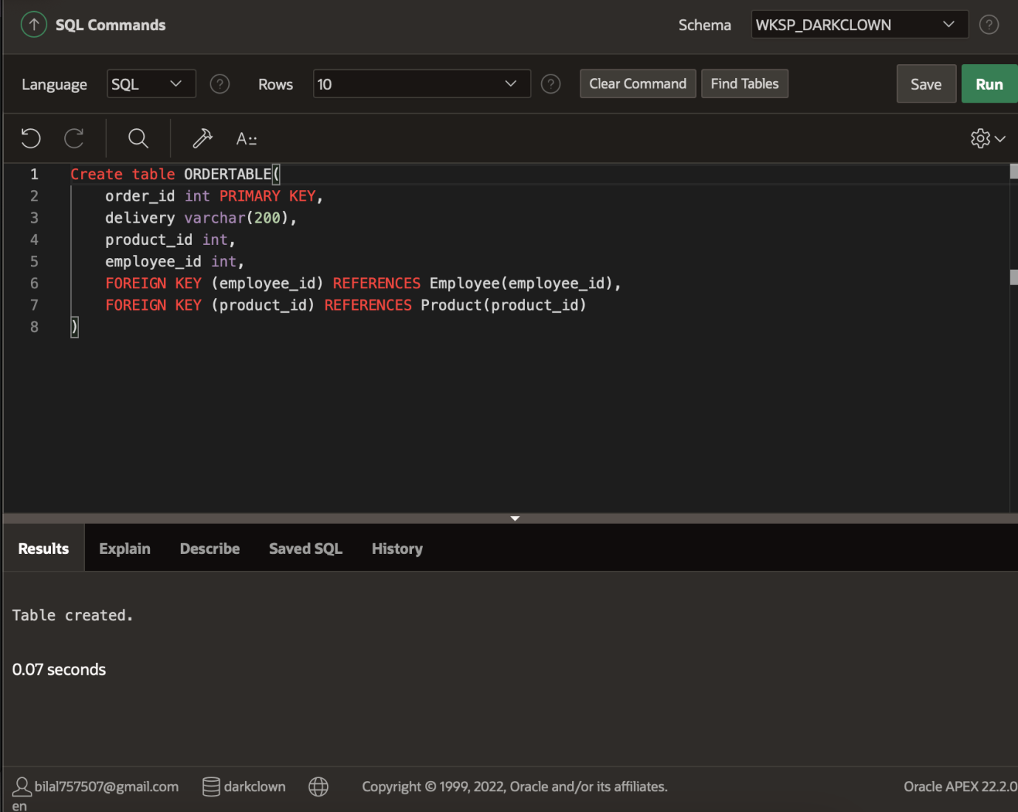

Create table ORDERTABLE(
order_id int PRIMARY KEY,
delivery varchar(200),
product_id int,
employee_id int,
FOREIGN KEY (employee_id) REFERENCES Employee(employee_id),
FOREIGN KEY (product_id) REFERENCES Product(product_id)
)

Insert Atleast 5 row in the table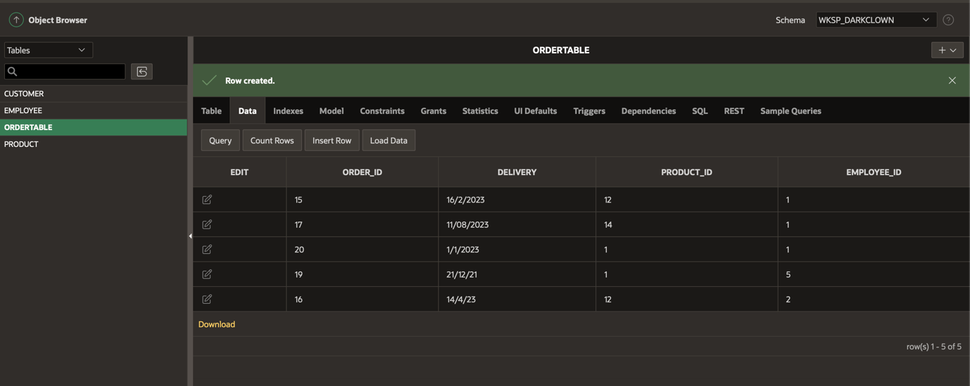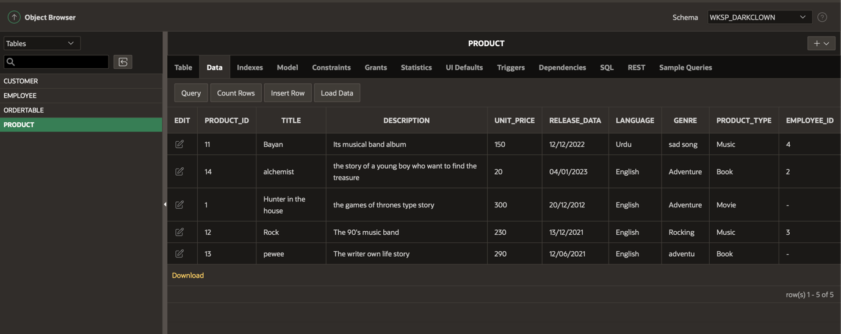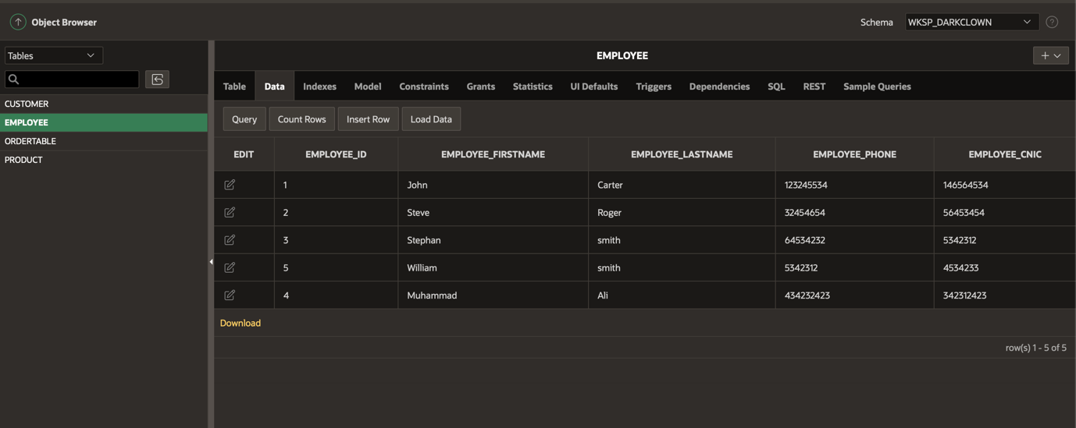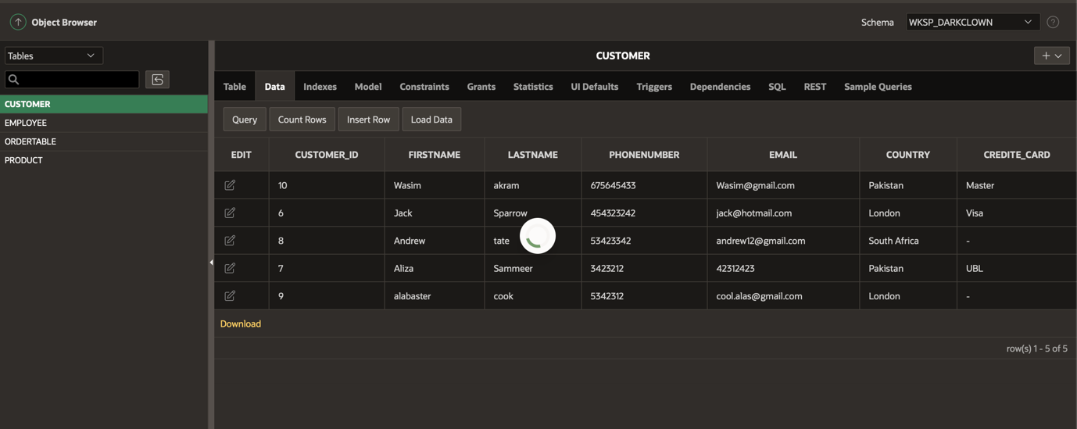

Sql queries:
Select * from Customer where city=="London";

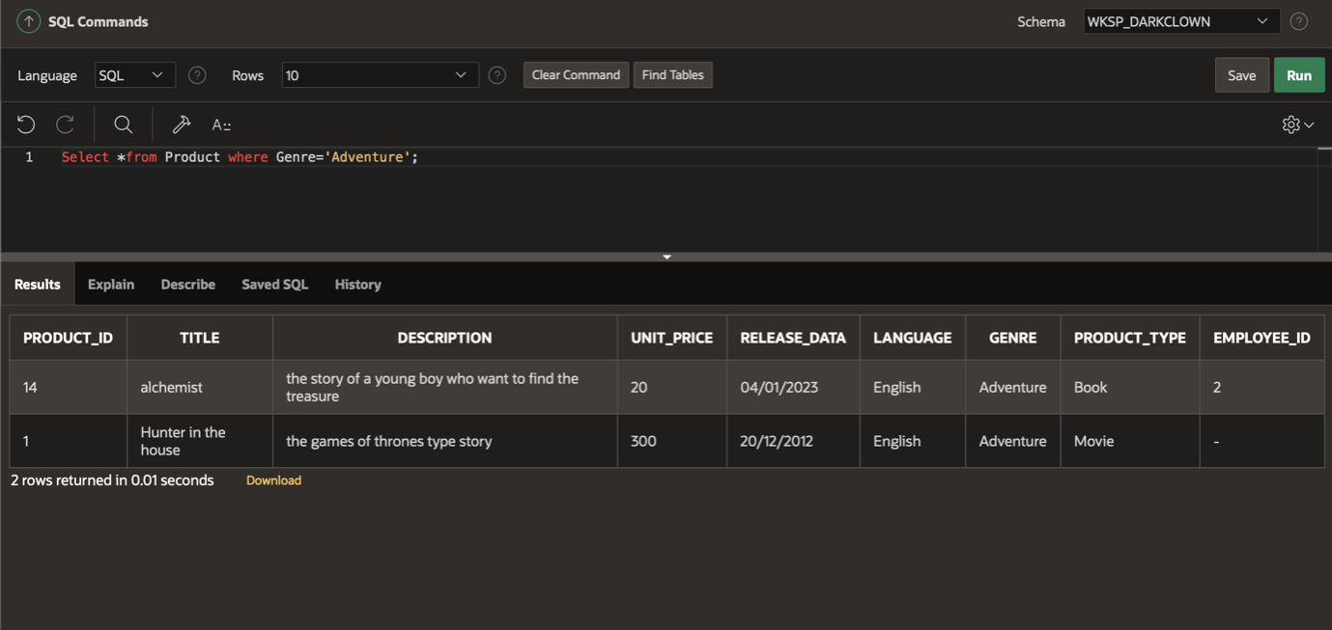

Select *from Product where Genre='Adventure';

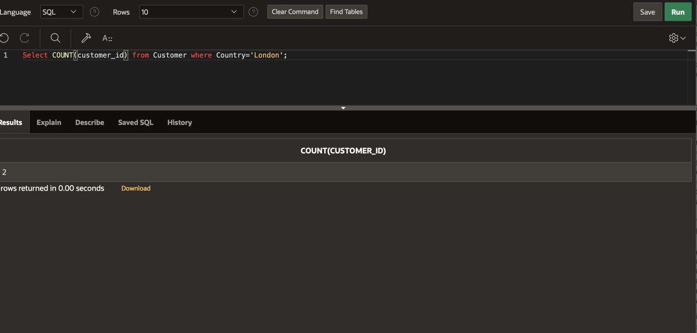
Select COUNT(customer_id) from Customer where Country='London';

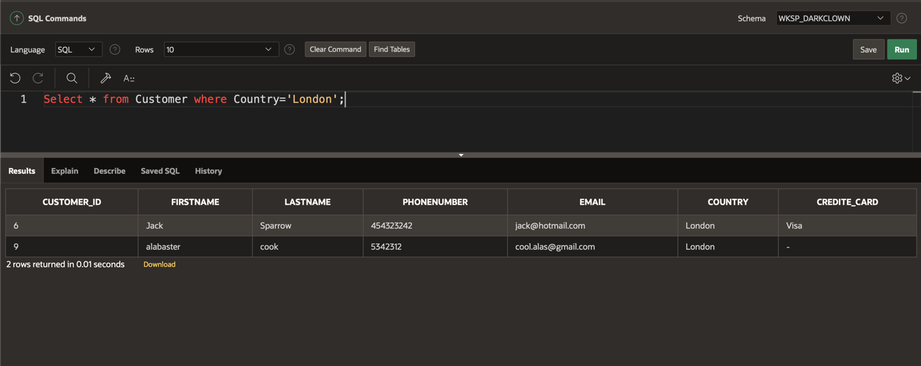
Select AVG(unit_price) from Product;
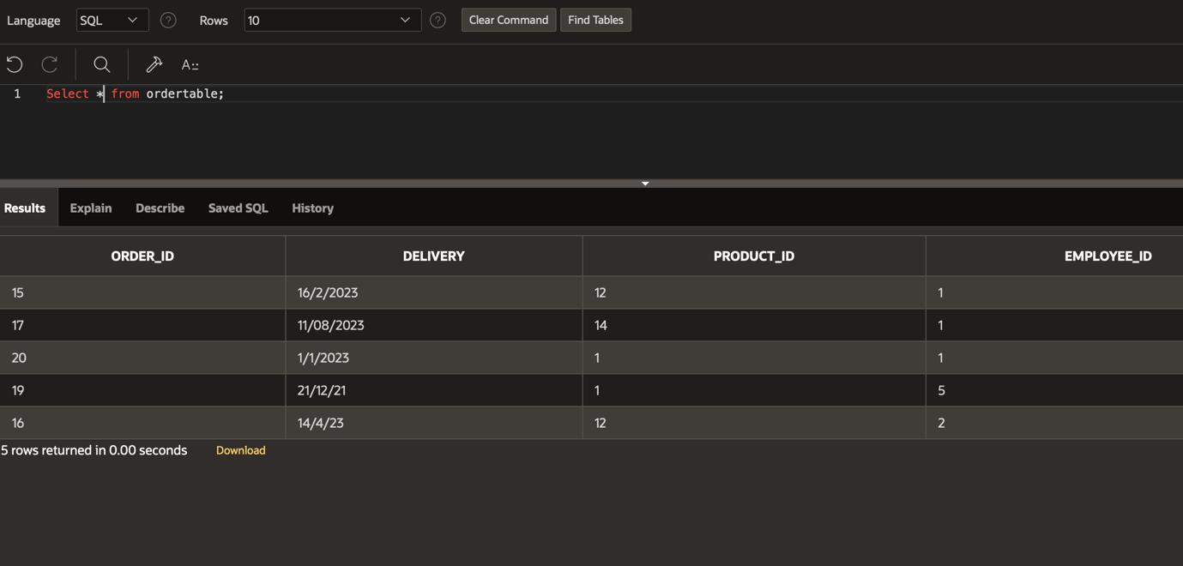

Select * from ordertable;
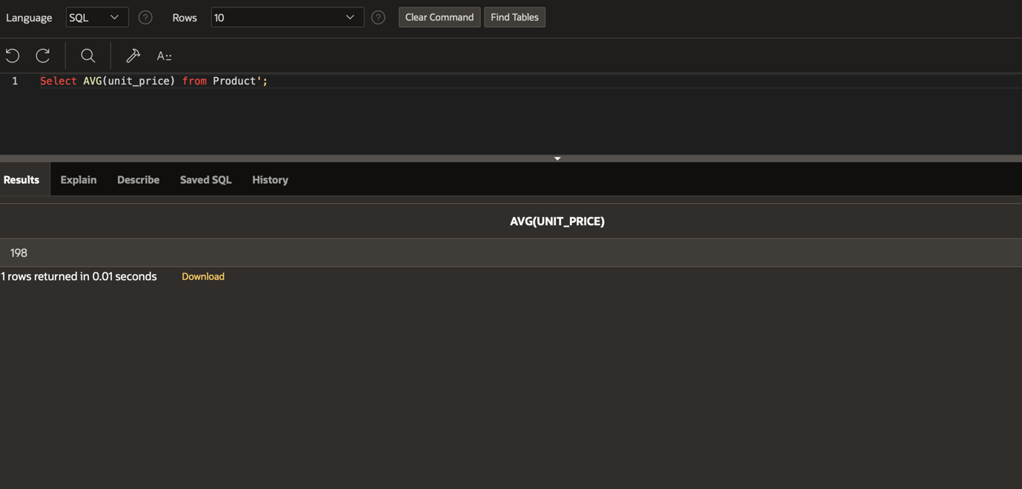
Select * from product where description = '%The';
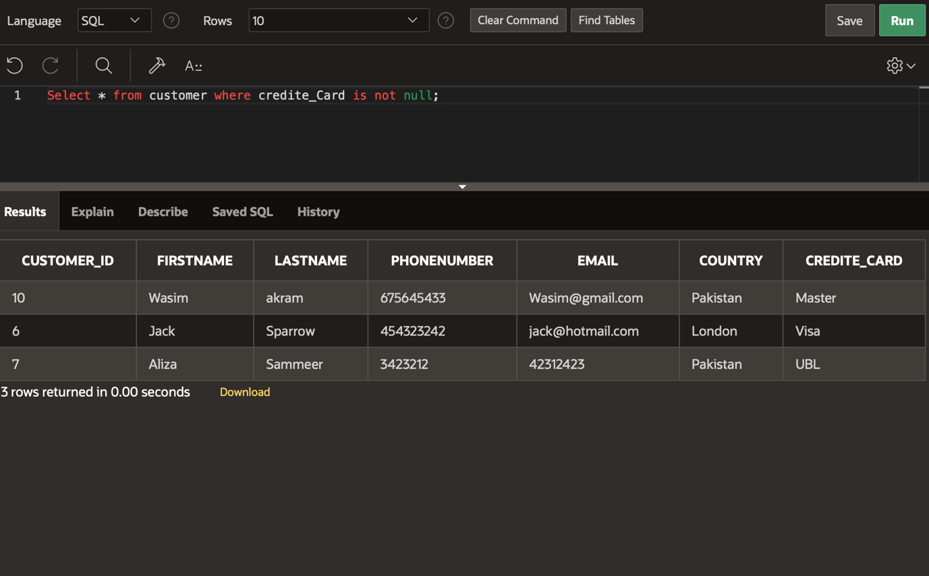

Select * from customer where credite_Card is not null;
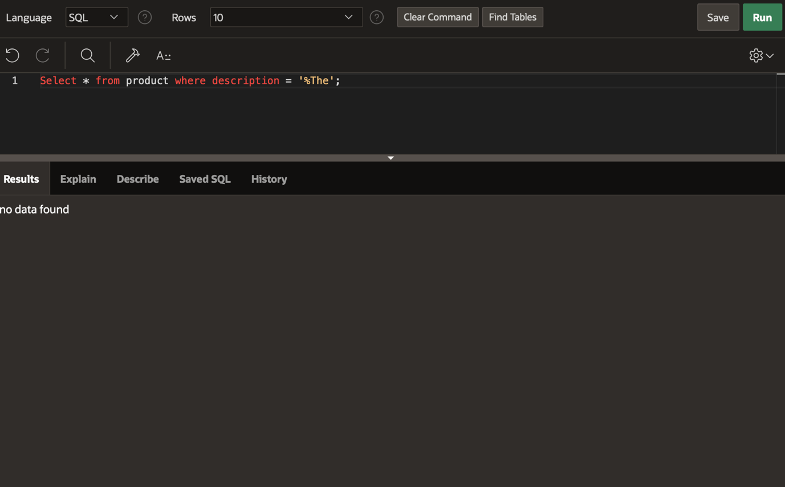
Select Count(employee_id) from product where employee_id is not null and product_type='Music';

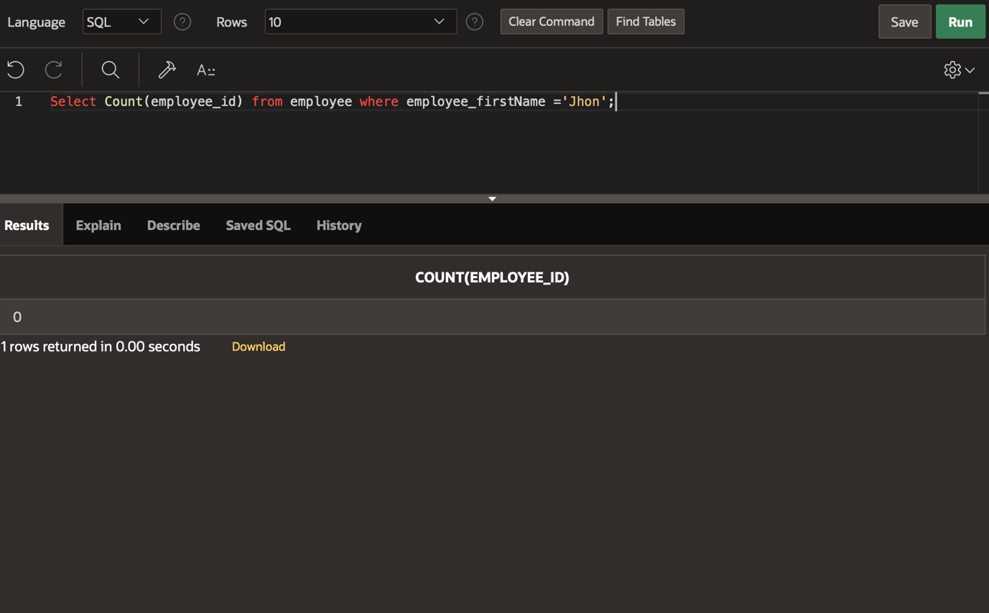
Select Count(employee_id) from employee where employee_firstName ='Jhon';
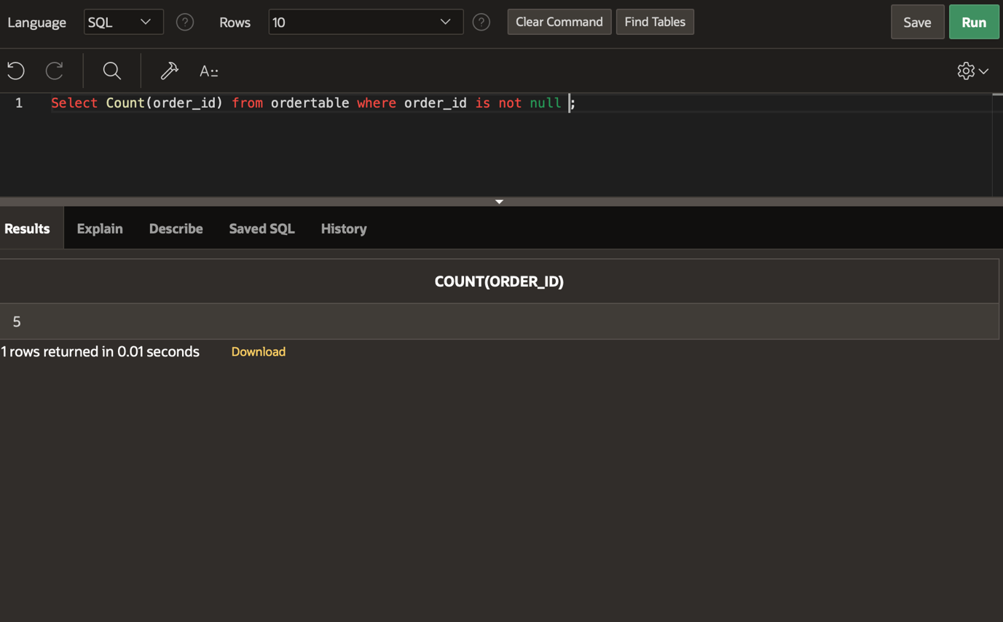
Select Count(order_id) from ordertable where order_id is not null ;
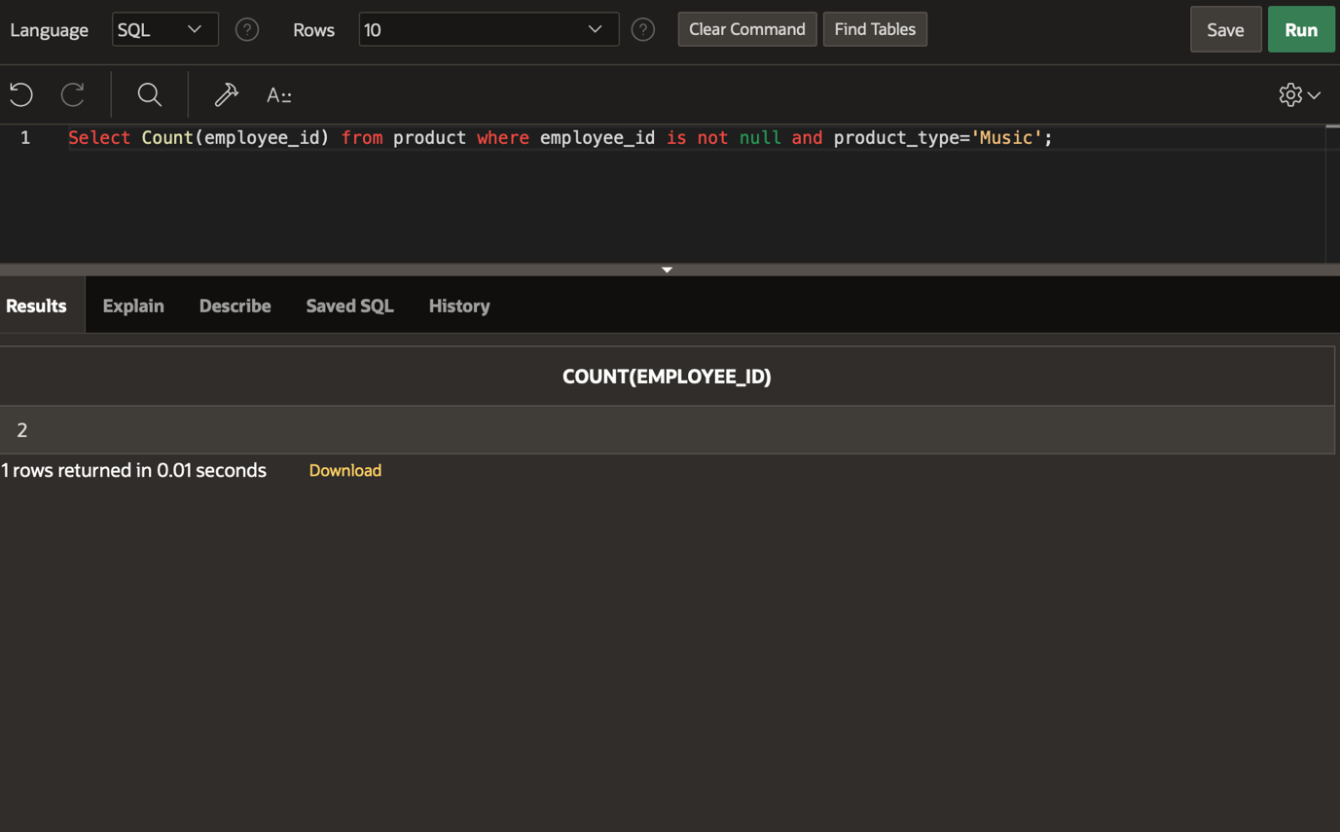

Use case:

