Title: How project management could be used more constructive and effective way in waste of project

Student name:
Student id:
Abstract
The recent study has presented an excellent account of project management in reducing or managing wastes generated with various organisational activities. Wastes are one of the major concerns which have a potential negative impact on society. Through the present work, the researcher has evaluated several strategies to use some of the negative impacts generated in the environment. Without suitable strategies for changing the waste management in projects has chances to generate a huge negative impact on the environment.
Through the present work the researcher has provided an explicit sample of waste management with that of project management by systematic review. Systematic literature review has allowed the researcher to analyse the findings of the previous work and present the valid conclusion. 14 articles published on or after 2015 were considered for the present study.
It has been noted in the below sections that strong collaboration and communication among stakeholders delivers better performance to companies, inclusion of modern technology in waste management is the valuable tool for the same. GIS, AI and other technology assist companies with waste management. This study focuses on the problem of residual garbage in London, where 1.59 million tonnes are annually dumped, raising environmental issues. The UK’s effort to achieve Net Zero Carbon may be hampered by incinerating waste. It places a focus on open data for formulating policies. Key players Biffa waste services and Vinidor both have different environmental philosophies. The study investigates the sustainability of recycling offensive human faeces.
In conclusion, the study has been able to emphasise the critical significance of proactive waste management in organisations by highlighting its impact on cost, environmental responsibility and public perception. It advocates adopting advanced recycling practices. Collaboration with stakeholders and waste valorisation are considered to be vital steps toward sustainable waste management.
Acknowledgement
The real help and support behind finishing this dissertation is provided by my supervisor. Because of this help, I was able to complete this dissertation despite its difficulties and adhere to the requirements established at the ethical submission stage. Additionally, the knowledge and information exchanged about this technology endeavour helps me develop better and more useful career abilities. Additionally, I want to thank my parents and friends for helping me find solutions to the challenges I had while working on this project and for their encouragement at difficult moments.
Regards,
Student Name
Student ID

Table of Contents
1.0 Chapter 1: Introduction 5
1.1 Introduction 5
1.2 Background 5
1.3 Significance 6
1.4 Rationale 6
1.5 Research aim and objectives 7
1.6 Research question 7
1.7 Methods followed to meet research objectives 7
1.7 Structure of the Dissertation 9
1.8 Summary 10
2.0 Chapter 2: Literature review 11
2.1 Introduction 11
2.2 Theoretical and Conceptual Framework 11
2.3 Project Management in Construction vs. Waste Management 12
2.4 Key Project Management Principles for Waste Management 14
2.5 Environmental Impact Assessment and Risk Management 14
2.6 Stakeholder Engagement and Communication 15
2.7 Sustainable Practices and Resource Allocation 17
2.8 Technology Integration and Innovation 18
2.9 Research Gap 19
2.10 Summary 19
Chapter 3 Findings and discussion 21
3.1 Introduction 21
3.2 Effect of wastes in companies 21
3.3 Strategies of waste management in companies 22
3.4 Waste management practises in companies 24
3.5 Interdependence of project managers and waste management 25
3.6 Discussion 26
3.7 Summary 29
Chapter 4: Conclusion and Recommendation 30
4.1 Conclusion 30
4.2 Linking with objectives 31
4.3 Recommendation 31
4.4 Limitation of the study 32
4.5 Future scope 32
References 33

List of Figures
Figure 1:Critical Path Method 14
Figure 2: Construction Waste For Residential Project 15
Figure 3: EIA Cycle 17
Figure 4: Stakeholder matrix for waste management 18
Figure 5: Internet of Things based smart waste management process 21
Figure 6: Recent strategy of using technology in waste management. 26

1.0 Chapter 1: Introduction

1.1 Introduction
Waste management is associated with activities required for waste disposal and management of waste for a better quality environment. Companies are the major contributor towards waste generation through their several activities. Waste reduction positively contributes a step forward towards environmental protection and a significant reduction of expenses related to cost. Reduction in waste contributes to managing the environment from the effect of toxic chemicals released into nature (Nanda and Berriti, 2021). In the past few years waste management has been a serious concern for companies. The increasing population is associated with enhanced waste which requires strict steps in managing. Modernisation is increasing waste and is leading companies to observe suitable strategies to manage the same.
Different forms of the project deal with toxic chemicals, and hazardous waste that contribute towards the overall increase of waste in the environment. By observing various steps in managing and disposing of waste, companies might move forward with better brand value and convey a positive message towards consumers. Recycling and disposal are the most common forms of waste management which deliver companies with the ability to provide sustainability to the environment and better resilience to organisational policies (Li et al., 2020). Companies need to take suitable strategies to manage waste throughout the project life cycle. The present work will be evaluating comparative strategic variation among companies relating to waste management.

1.2 Background
Waste generation has been a serious and alarming concern directing companies towards the adoption of newer strategies to assist the environment in retaining sustainability. Failure to manage the waste or any form of negligence in waste management is solely related to the negative impact on organisational activity and brand value. According to a source, it has been identified that municipal solid waste is targeted to reach 3.4 billion through an increase of 70%. The source also stated that the percentage of waste recycled every year is only 20% which is quite lower and also an alarming fact. It is quite interesting to note that waste generation is more prevalent in richer countries compared to developing nations. According to Alves (2023), waste has been noted to be the highest in the United States with about 265.0 metric tonnes annually. With the change in lifestyle patterns, the number of factors is increasing at an exponential rate. According to the opinion of Carippa et al. (2022), alterations in the shopping habits of consumers, urbanisation, economic growth, and population are the major contributors towards increased solid waste generation.
Apart from the generation of municipal solid waste, industrial waste is another concern which is closely associated with an increased percentage of waste generation. In most cases, waste generation is associated with insufficient use of materials. Chemical waste, and hazardous materials, are also on the list of waste materials generated by different sources (Noor et al., 2020). Reviewing the potential and future trends in waste generation it has become essential for projects to pay utmost generation to managing waste for the sole purpose of maintaining a healthy and pollution-free life. Moreover, waste management in projects is a step forward in retaining sustainability.

1.3 Significance
Considering the above statistics it might bestated that companies should take utmost care in managing different forms of waste to retain their organisational values. Appropriate association with waste management strategies assist companies to display better coherence with corporate social responsibility strategies and at the same time it helps companies to go with predefined national and international policies. According to a relevant source, it has been noted that waste generation in high-income countries is projected to increase by 19% by 2050. The source also stated that most of the waste is generated by the food industry (44%) with the lowest percentage in the rubber leather industry and wood industry. Accounting for waste management it can be noted that the emission of carbon dioxide related to solid waste is projected to reach 2.38 billion tons by 2050 (worldbank, 2022). Reviewing all the statistical implications it might be commented that appropriate strategies in managing waste in different projects should be considered with priority. In this context, the present study is apt and has a chance to generate awareness among the concerned authorities.

1.4 Rationale
The present work will evaluate the project management strategies with a focus on managing waste to provide better living standards to future generations. All forms of waste are increasing in the coming days and are becoming a major threat to the future world. The generation of carbon dioxide will be increased if waste management is not done in a suitable mode. Improper waste disposal is recognised as one of the most negative concerns for health. The present study will evaluate the different strategies and factors used by companies in managing waste (Rajmohan et al., 2019). Adopting suitable strategies in waste management guides organisations through better resilience towards retaining transparency and organisational values.

1.5 Research aim and objectives
The primary aim of the project is to comparatively analyse the strategies of 5 different waste management companies to frame their dedication and strategies to resolve the waste management concern associated with project management.
The objectives associated with the recent work are as follows
- To critically evaluate the interrelationship of waste management and project management.
- To analyse how the waste management companies are dealing with waste in different projects.
- To recognise the critical factors that resulted in reducing waste by the companies in different projects.
- To identify best practices in reducing waste and ensure suitable completion of projects.

1.6 Research question
- What is the interrelationship of project management and waste management?
- What are the impacts of different types of waste faced by waste management companies with project management?
- What are the factors resulting in reducing the wastages in projects admired by the companies?
- What are the best practices in waste reduction and successful management of projects?

1.7 Methods followed to meet research objectives
The present study will be adopting the path of systematic review to fulfil the demand of the research aims and objectives. According to the opinion of Psul et al. (2021), systematic review presents an authoritative account on the scholarly articles, through the adoption of reliable and reproducible research practises. Inclusion of systematic review in this research has allowed the researcher to accept detailed analysis of information presented in a particular research article. More precisely it might be stated that systematic reviews are concerned with presenting an overall view of the methods, findings and views expressed in that particular study (Linnenluecke, Marrone and Singh, 2020). The approach of Systematic review adopted in the present study has assisted the researcher to analyse and evaluate the findings provided in a particular study to identify the core findings and relate with the research aims. Inclusion of systematic review requires identifying articles most according to the research title.
The researcher has used Google and Firefox as the browser for the present work. Articles were selected on the basis of some keywords such as waste management, project management and some other factors. Articles were selected on the basis of the criteria for the study
Inclusion criteria
- Articles published after 2015 rejected from the final list of articles.
- Articles available as all PDF were selected for the study.
- Articles available in English languages were included for the study.
- Articles published in waste management strategies of companies were selected for the study.
Exclusion criteria
Exclusion criteria standardised for the present study are specified below
- Articles published before 2015 were not included in the study.
- Articles available as abstract were not included in the study.
- Articles available in languages other than English were not included in the study.
- Any difficulty in interpretation of the findings of the study was judged as the criteria for exclusion of the study.
- Articles published on other topics other than waste management in projects were excluded from the present work.
- Review articles were not chosen for the study.
Data collection is the most crucial part of any research work without which a research study is not completed (Mazhar et al. 2023). The researcher followed strict guidelines to select articles for the study. The researcher used Google as a browser for identifying the articles as most of the articles were available in this platform. Journals from ScienceDirect, Willey, Springer and PlosOne were finally selected for the study. Any repetition of articles was avoided to defer from any form of repetition of information. The researcher has finally selected 15 articles to interpret the findings associated with waste management for the recent work. The flow of selection of articles has been presented through the PRISMA framework as stated below.
Data analysis is the next stage followed by data collection, without which the central theme of the data can not be revealed. Systematic review being another form of secondary or qualitative data collection thus it has been supported by thematic analysis based on case studies and statistical findings. Thematic analysis is a form to develop subheadings and categorise the information according to the same (Braun, Clark and Hayfield, 2023). The researcher has constructed themes to support the central query of the research aim and objectives.

1.7 Structure of the Dissertation
CHAPTER 1: INTRODUCTION | Background, rationale, significance n aim and objective discussed
CHAPTER 2: LITERATURE REVIEW | Insight into literature
CHAPTER 3: FINDINGS AND DISCUSSION | Brief overview principle findings a discussion supported by literary pieces.
CHAPTER 4: CONCLUSION AND RECOMMENDATION | Overall conclusion with recommendation based on findings.

1.8 Summary
From the above discussion, it has been noted that waste generation is a major concern which requires following suitable management strategies. It has been identified from the above section that solid waste generation is higher in high-income countries and is adversely affected by lifestyle. Improper management of waste will lead to a huge increase in carbon dioxide generation and adverse effects on the health status of individuals. Adopting appropriate strategies to manage waste in different projects is the core requirement for the purpose of retaining sustainability, and conserving natural resources for the future.

2.0 Chapter 2: Literature review

2.1 Introduction
The literature review chapter's opening covers a number of important topics. It investigates the theoretical and conceptual foundations of project management in the fields of building and waste management. A comparison of these domains reveals important concepts particular to waste management. In both situations, risk management techniques and environmental impact assessments are essential. Project success depends on effective stakeholder participation and communication. Environmental advantages are maximised when sustainable practices and resource allocation are combined. Additionally, innovation and technology integration advance waste management techniques. This chapter prepares the reader for the upcoming parts' thorough investigation of these related subjects.

2.2 Theoretical and Conceptual Framework
According to Salhab et al. (2022), construction efficiency and effectiveness can be greatly increased in the field of waste management projects by implementing project management approaches, particularly the Critical Path Method (CPM). A more streamlined method to planning, scheduling, and regulating project operations is provided by CPM, enabling better waste management. The theoretical foundation of CPM places a strong emphasis on identifying key tasks that have a direct impact on project completion time (ElSahly, Ahmed and Abdelfatah, 2023). This pertains to trash management and identifies crucial processes such as waste collection, transportation, disposal, and recycling. Project managers can construct a thorough schedule that reduces bottlenecks and maximises resource allocation by figuring out the order and duration of these actions.
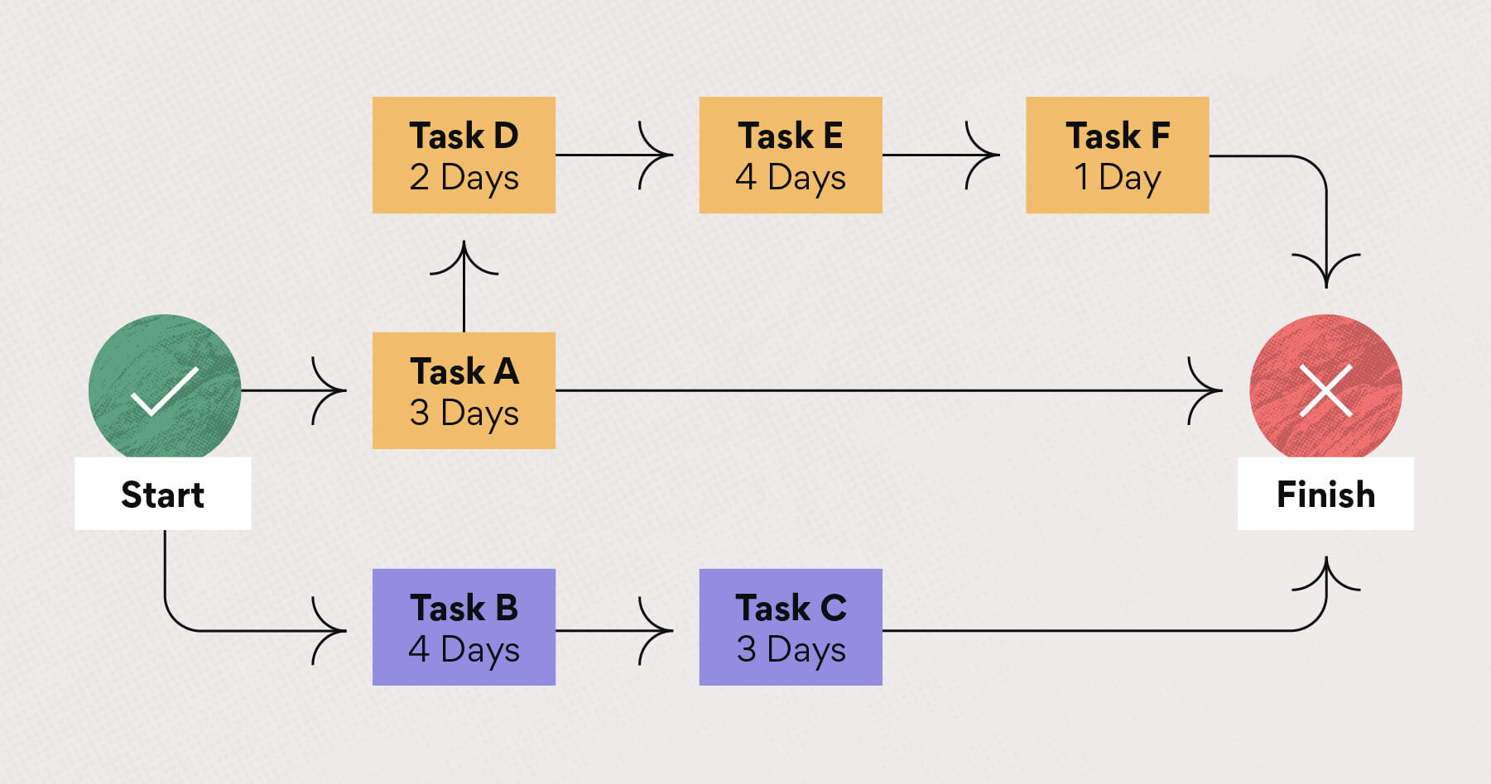
Figure 1:Critical Path Method
Source: (Salhab et al., 2022)
According to Goel, Ganesh and Kaur (2020), among project stakeholders, the conceptual framework of CPM further encourages good communication and collaboration. Clear communication is essential in the management of garbage, which involves a number of different entities including local authorities, waste sources, and disposal facilities. Project managers can create a shared schedule and expectations with CPM, which improves cooperation and decreases delays. Furthermore, the urgency and regulatory restraints associated with waste management are nicely matched by CPM's emphasis on time management. It makes it possible to identify tasks that can be expedited or changed in order to fulfil deadlines and maintain environmental standards. Task interdependencies are taken into account by CPM, which reduces the risk of delays brought on by unplanned events or adjustments to waste generation patterns.

2.3 Project Management in Construction vs. Waste Management
According to Stanitsas, Kirytopoulos and Leopoulos (2021), despite serving very diverse industries, project management in the construction and waste management fields have basic concepts. Both disciplines strive to achieve desired results by streamlining processes, wisely allocating resources, and maximising output. Project management in the building industry is organising, caring out, and keeping track of construction projects in order to guarantee their prompt completion and adhere to budgetary restrictions. Diverse parties must be brought together, hazards must be managed, and safety regulations used or significant infrastructure expansions are both examples of construction projects. However, by effectively gathering, transporting, processing, and discarding waste, on the other hand, seeks to reduce the impact of waste on the environment. Designing waste collection routes, putting recycling programs in place, and following rules are all part of waste management project management. The objective is to encourage recycling, lessen the amount of waste sent to landfills, and responsibly handle hazardous waste.
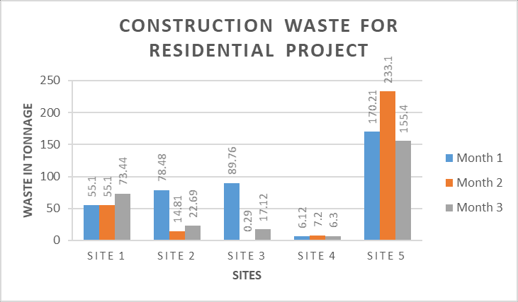
Figure 2: Construction Waste For Residential Project
Source: (Stanitsas, Kirytopoulos and Leopoulos, 2021)
According to Stephany et al. (2020), effective budget management, risk assessment, and communication are essential in both industries. While waste management project managers must deal with shifting regulations, technological breakthroughs, and sustainable practices, building project managers must supervise intricate timetables, resource allocation, and construction processes. Waste management demands continual work to address expanding waste streams and environmental problems, whereas construction projects are frequently one-time endeavours. Construction focuses on building tangible goods, and waste management works to reduce the harm these items do after their useful lives. Finally, even though waste management and construction project management work in distinct fields, they both adhere to the same basic project management concepts. Both sectors work to efficiently accomplish goals, stay within budgets, and reduce risks, thereby enhancing the performance of their respective enterprises.

2.4 Key Project Management Principles for Waste Management
According to Eddoug, Benhra and Benabbou (2022), the successful planning, execution, and monitoring of waste-related activities depend on adherence to fundamental project management principles. The first step is to clearly define the goals. All future operations will be guided by clearly defined objectives that assist define the aim and scope of the waste management project. Second, meticulous planning is essential. However, to keep the project on track, a detailed project plan that specifies activities, deadlines, resource allocation, and risk management techniques is essential. Communication is also essential. Achieving alignment, managing expectations, and swiftly addressing possible difficulties requires open and honest communication with stakeholders, team members and the appropriate authorities (Moerschell and Novak, 2020). The management and allocation of resources must be carefully balanced. Making the appropriate manpower, equipment, and financial allocations ensures that the project may advance effectively and within the allocated budget.
Management of risks cannot be disregarded. Enhancing the project’s resilience and reducing interruptions requires identifying potential obstacles, evaluating their effects, and developing backup strategies (Hussain and Musilek, 2022). Regular evaluation and monitoring offer information on project performance. Key performance indicators can be monitored and compared to predetermined targets to enable timely corrections and advancements as required. Finally, success is fostered by collaboration and teamwork. Project outcomes are improved by encouraging a collaborative environment where team members may exchange ideas, work together to solve problems, and take use of one another’s talents. These project management tenets can be applied to waste management programs to improve efficiency, lessen negative environmental effects, and promote sustainable waste reduction and disposal methods.

2.5 Environmental Impact Assessment and Risk Management
According to Kabir and Khan (2020), the environmental impact assessment (EIA) process is essential for waste management projects, as it assesses the potential environmental effects prior to implementation. EIA helps to ensure that waste disposal, processing, and recycling initiatives are carried out in a responsible manner, with minimal harm to the environment and local communities (Yu et al., 2021). It identifies potential impacts such as pollution of air and water, habitat destruction, and public health issues, and provides guidance to decision-makers in order to adopt mitigation strategies and improve planning.
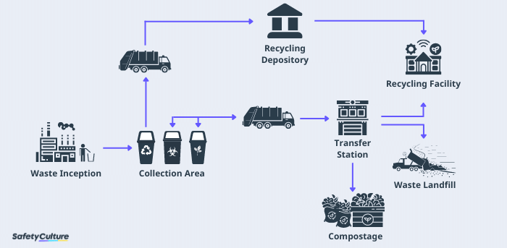
Figure 3: EIA Cycle
Source: ((Yu et al., 2021)
Risk management is an essential element of waste management, as it identifies, assesses, and addresses potential risks associated with a waste management project. Proper risk management reduces the likelihood of accidents and contamination, as well as other adverse effects. However, inadequate risk management can result in catastrophic outcomes. For example, the Bhopal gas disaster in India, which was caused by inadequate safety measures in the waste management process, resulted in extensive environmental damage and the loss of human life (Shareefdeen and Bhojwani, 2022). In the United States, the Love Canal disaster was also a result of poor risk management, as it contaminated an entire residential area and caused serious health issues for residents (Agbotui et al., 2022). EIA plays an essential role in waste management projects in order to anticipate potential environmental effects. When combined with appropriate risk management, EIA ensures that adverse effects are minimised. Poor risk management has resulted in devastating environmental catastrophes, emphasising the importance of careful planning and mitigation measures in waste management projects.

2.6 Stakeholder Engagement and Communication
According to Lehtinen and Aaltonen (2020), effective project management strategies, with a particular emphasis on stakeholder participation and communication, can greatly improve project outcomes in the area of waste management initiatives. Identification and participation of persons or groups with a stake in the project's success are required for stakeholder engagement. Local governments, governing bodies, environmental groups, and even garbage collection and disposal service companies may be involved in waste management programs. First and foremost, detailed stakeholder analysis aids in identifying the worries, demands, and hopes of these various groups. Project managers can use this knowledge to create communication plans that target certain problems and promote wholesome relationships.
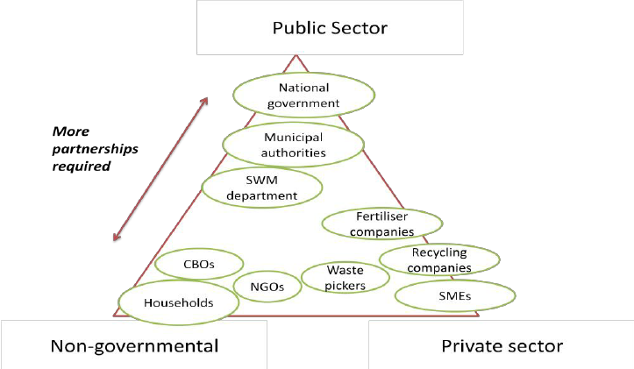
Figure 4: Stakeholder matrix for waste management
Source: (Lehtinen and Aaltonen, 2020)
Continuous discussion can be facilitated via regular meetings, workshops, and online forums, ensuring stakeholders feel heard and participated throughout the project lifecycle. In waste management projects, effective communication is crucial (Kabirifar et al., 2020). Building trust among stakeholders requires open and honest communication about the objectives, schedule, risks, and mitigation measures of a project. Furthermore, using a range of communication channels—including newsletters, social media, and public presentations—ensures that information reaches various demographic groups. Engagement of stakeholders also helps to win support for waste management projects. Projects are more likely to be accepted by society and encounter less resistance when they involve local communities and address their concerns. This can speed up regulatory clearances, shorten project delays, and improve project effectiveness all around. Overall, it is critical for waste management initiatives to incorporate reliable project management approaches with a strong emphasis on stakeholder interaction and communication.

2.7 Sustainable Practices and Resource Allocation
According to Randhawa et al. (2020), the incorporation of sustainable techniques into waste management initiatives is greatly aided by project management. Project managers can make sure that environmental considerations are incorporated into project planning, execution, and monitoring by adhering to established frameworks like the PMBOK published by the Project Management Institute (Simonaitis, Daukšys and Mockienė, 2023). A careful balance of material, human, and technical resources is necessary for effective waste management. Systems for sorting waste, recycling infrastructure, and renewable energy sources might all receive financial support. Human resources are crucial for training staff, educating communities, and ensuring adherence to sustainable practices. Efficiency is improved through technological resources including cutting-edge sorting methods and waste-to-energy procedures.
According to Tsalis et al. (2020), numerous waste management initiatives serve as successful examples of how to allocate resources in a sustainable way. Moreover, by investing in community education, effective garbage sorting, and creative recycling methods, the Kamikatsu Zero garbage Project in Japan was able to accomplish outstanding results. However, by taxing citizens according to the amount of rubbish they produce and incentivizing waste reduction, the "Pay As You Throw" program in several European communities effectively distributes financial resources (Ukkonen, A. and Sahimaa, 2021). Additionally, the "Trash to Cash" effort uses technology resources in impoverished countries to transform garbage into useful resources (Chidepatil et al. 2020). However, project management techniques are crucial for integrating sustainability into waste management programs. The accomplishment of sustainability objectives is ensured through the efficient allocation of financial, human, and technological resources. The efficacy of this strategy is illustrated by several examples, which show the beneficial effect of resource allocation on the accomplishment of waste management initiatives.

2.8 Technology Integration and Innovation
The use of technology to improve efficiency, sustainability, and effectiveness in waste management projects is crucial. According to Qureshi et al. (2023), processes for managing trash can be completely transformed by incorporating cutting-edge technologies like the Internet of Things (IoT) and data analytics. Real-time monitoring of trash cans made possible by IoT allows for the optimization of garbage truck routes and timetables, resulting in lower operational costs and lessening of environmental effect. Data analytics helps with trend detection, waste sorting optimization, and waste creation pattern prediction, further improving resource allocation and decision-making (He et al., 2022). The integration of these cutting-edge technologies depends critically on effective project management. Setting specific goals, allocating resources, assessing risks, and involving stakeholders are all part of it. However, to guarantee alignment with project objectives, project managers make sure that stakeholders, waste management professionals, and technology providers all communicate effectively.
They supervise implementation schedules, keep tabs on development, and swiftly resolve issues to encourage successful technological integration. The effective fusion of project management and technology is demonstrated by a number of waste management initiatives. The "Smart Waste Management" effort in Barcelona, for instance, used IoT sensors to track waste levels in real-time and cut collection frequency by 20% (Teh and Rana, 2023). Similar to this, Singapore's "Waste-to-Energy" plant used data analytics to improve the energy production from waste, considerably lowering the need for landfill space. Strong project management made it feasible for these outcomes by ensuring stakeholder cooperation, crystal-clear implementation strategies, and flexibility to meet changing requirements.
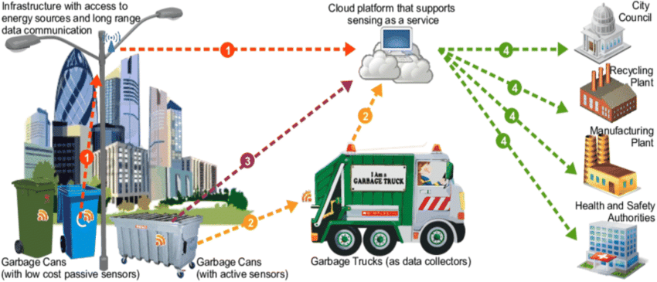
Figure 5: Internet of Things based smart waste management process
Source: (Teh and Rana, 2023)

2.9 Research Gap
Lack of research on the social and cultural influences on waste management project management may be the root of the study’s research gap. The effectiveness with which waste management projects involve stakeholders, are embraced by the community, and are ultimately successful may be greatly influenced by these factors. It can be beneficial to execute plans more successfully and achieve better project results by understanding how local beliefs, customs, and perceptions interact with project management approaches. This element is crucial because it broadens understanding of waste management initiatives beyond just their technical and operational aspects, improving their sustainability and overall efficacy.

2.10 Summary
The advantages of using project management techniques, notably the Critical Path Method (CPM), for waste management projects are covered in this passage. Planning, scheduling, and regulating waste management operations can be made more efficient by using CPM. The CPM conceptual framework promotes stakeholder cooperation and communication, which is essential in waste management given the involvement of numerous entities. The section underlines how budget management, risk assessment, and communication are fundamental concepts shared by waste management and construction project management. In order to predict and reduce potential negative effects, environmental impact assessments (EIA) and risk management are essential components of waste management. The success of a project depends on stakeholder involvement and communication, and efficient waste management also depends on sustainable practices, resource allocation, technological integration, and innovation.

Chapter 3 Findings and discussion

3.1 Introduction
The present section will focus on different aspects of waste management in the industries. Waste management is becoming a major concern for the governments and company officials. With major focus on various strategies used by companies in managing wastes provides the approach to establish better organisational values to the companies. In this section the researcher has discussed strategies adopted by companies with its impact on the organisation. Interrelation of project management and waste management has been discussed with specific waste management practises.

3.2 Effect of wastes in companies
Waste generation has been noted to have several negative impacts on organisational performance, outcomes of the companies. Some of the negative impacts include increase of cost, and building negative impressions among others revealing the negligence of the company regarding reduction of carbon footprint and deviation of sustainability issues. Release of greenhouse gases, disruption of the ecosystem is another step to continue with the same. According to the findings of Mousavi et al. (2019), managing waste water is one of the most ealterationffective challenges that allows any organisation to continue and move forward to its estimated goal. Amount of wastewater is and addition of chemicals to the water body can be recognised as one of the most potential factors affecting the water and everyday life. The study noted that foaming, eutrophication, and water characteristics (turbidity, salimity, temperature and pH) are mostly evidenced.
Challenges faced by waste water treatment has been one of the most potential concerns. Another study conducted by Choudhury et al. (2019), found that release of water prior to treatment causes major health risk to the habitat residing there. The study noted that waste water treatment encounters several issues relating to onset of unpredictable environmental issues, negative impact on health status in the surrounding community, as well as unpredicted cost effectiveness. The study has suggested that adoption of the best possible approach to minimise the risk in concerned with waste management can be addressed with high performance and cost effective strategies.
Another most concerning effect associated with waste management relates to generation of plastic wastes through locations. The onset of covid 19 pandemic has generated the concern of managing plastic waste with most effective policies. The study conducted by Klemeš (2020), revealed that plastic waste is an akar kmg concern for health status of individuals. Plastic waste footprint has been noticed to capture environmental footprint through the entire life cycle of the plastic products. On the other side destruction of household pathogens are also resulting in negative issues with destruction of wastes.

3.3 Strategies of waste management in companies
Waste management strategies are one of the prime concerns of different sectors converting to major societal impacts. The study conducted by Filimonau and Delysia (2019), noted that hospitality sectors are one of major contributors in waste management relating to generation of food waste. The hospitality sectors are providing significant challenges to the society through generation of food wastes. The study has efficiently derived a series of practices to mitigate the negative impacts created by food waste. The present study has developed an effective framework through development of effective mitigation strategies by implementing a vast training schedule, developing core inhouse competencies, effective savings in terms of monetary expenses and initial investment in the same. Apart from the above recommendation the authors also proposed maintaining movement of wastes from its point of generation, recirculation of wastes, and providing better inside that perspective.
Waste management is somehow associated with managing solid wastes through the different locations. According to the opinion of Das et al. (2019), reduce, reuse and recycle are the most effective strategies undertaken by the companies. The study has suggested that adoption of the above suggested strategy is the best possible initiative that might be undertaken in this perspective. Managing solid waste initiated from waste generation with segregation, storage and transfer and transport. The authors also suggest the adoption of life cycle assessment (LFA), while managing wastes. One most engaging strategy as stated by the author depicts the adoption consideration of economic and geographic position of the nation while monitoring the waste strategies. Ratnasabapathy, Perera, and Alashwal (2019), depicted that apart from the mentioned waste management approaches, inclusion of Geographical information systems, radio frequency identification or ultrasonic sensors may be used to collect waste from trucks and bins.
According to the evidence presented by Ratnasabapathy, Perera, and Alashwal (2019), use of smart technologies are effective in construction and demolition organisations as it offers better insight to the issues. The author has proposed that use of smart technologies provide better insight to managing solid waste. Shukja and Hait (2022), stated that issues concerned with waste generation in smart cities generate huge waste which can be addressed with inclusion of smart tools such as Artificial intelligence Internet of things (IoT), intelligent transportation system and some more. From the studies it has been noted that systems embedded with effective waste regulation techniques, assist authorities to manage wastes more effectively. Inclusion of RFID, evaluating waste lifecycle, aided with effective waste generation will support companies with the ability to manage wastes in more effective and impactful mode.
Inclusion of advanced technology in waste management is supported by another group of authurcin managing wastes in urban areas. According to the opinion of Hayat (2023), technology may be identified as one of the most significant tools to manage wastes especially in urban areas. Reviewing the strategy of waste management in urban areas the authors suggested the use of AI, as one of the most effective methods of waste management. The authors stated that dumping of waste in local areas is the major concern which are leading to waste mountain. Closure of those sites has become essential with inclusion of EIA. To conduct the same it is essential to use Aerial photography and remote sensing. According to the opinion of Akram et al. (2021), monitoring SWM might also be conducted through the inclusion of IoT, Geospatial technology. Maintaining wireless data communication can also be defined as another effective strategy to manage and reduce solid waste accordingly. The most recent approach implemented in managing solid waste can also be addressed with the inclusion of Blockchain technology.
The strategies discussed above with adoption and inclusion of modern technology are the best approach in managing waste through different locations around the globe.
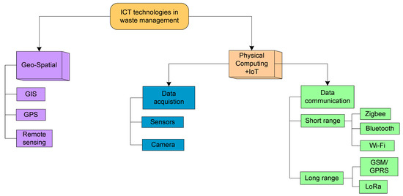
Figure 6: Recent strategy of using technology in waste management.
Source: (Akram et al. 2021)

3.4 Waste management practises in companies
Some of the waste management practises crucially used by companies mostly revolve around the adoption of reuse, recycling. As stated by Gong et al. (2020), stated that circular economy is one of the most adored practices used in the companies. The study has reported the adoption of various recyclable plastics plastics industries. Among the best practices used in plastic industries, recyclable wastes are best adopted. The companies suggest that unrecyclable plastic materials are removed at the earliest basis with significant strategic implications. In store retailers schemes with effective lebal modification are the practices used in companies. Internal collaboration with effective identification of barriers are the most engaging strategies used in companies.
Composite materials are increasing day by day in industries such as aerospace, automobile and wind energy. Materials with metal matrix composite or polymer matrix composite are becoming a huge concern in recent companies. According to the views of Shuaib et al. (2021), to mitigate the wastes companies are using composite recycling techniques. Moreover, the study also suggested the practice of using circular economy in managing wastes is an effective method. Concerning the recent perspectives in the waste management industries, the act of using circular economy, recycling and composite recycling techniques will assist the company with best approach in dealing wastes.

3.5 Interdependence of project managers and waste management
Waste management is gaining significant attention among the stahildrs of projects. According to the opinion of Yuan et al. (2018), project managers are owed with serious waste reduction intention to prioritise the same with proper interrelation with project management. The study has crucially evaluated the intention of the project managers in adopting waste management strategies. Interpreting the factors directing the intentions of the project managers in implementing waste management strategies in companies. The study used primary data collected from company managers to identify the intentions of the same in implementing waste reduction strategies in companies.
In the opinion of Wu, Ann and Shen (2017), it has been noted that construction waste is recognised as one of the most crucial factors affecting sustainability in several locations of China. As per the view of this author, the active role of contractors inputs positive impact in managing wastes through the construction projects. The study conducted a survey to identify the role of contractors in waste demolition through construction projects. It has been identified by the authors that waste management approaches of contractors are supported by economic viability and also initiatives undertaken by the governments. Another study conducted by Lui, Yi and Wang (2020), specified that reducing hazardous chemicals in construction wastes is based on several factors. Lack of suitable policy, government initiatives, improper waste management system affect the entire process. It has been revealed from the study that nine different factors affect the waste management process significantly. A primary study conducted by the author revealed that understanding of the stakeholders in reducing waste plays a crucial role in waste reduction. Moreover, it has also been revealed that better understanding between constructor and stakeholder will guide the projects towards better waste management.
Wastes are one of the major concerns affecting society, economy and environment which can be addressed with suitable strategies undertaken by the organisations. According to the views of Nawaz et al. (2022), the penalty can be one of the effective methods to eliminate the amount of construction and demolition waste. According to the authors survey conducted among the employees of the concrete and steel skeleton project, that amount of waste calculated by project managers was quite lower than the amount of actual waste generated. The study calculated a penalty cost which was noted to be quite higher than the estimated project cost. Revealing the outcome of the survey stated that imposing the estimated project cost as a penalty amount will be a step forward towards adoption of waste reduction initiatives by the company managers.
A report presented by Shooshtarian et al. (2022), nored that construction and demolition industries are major contributors in increased pollution and waste dumping at local areas. From the study it has been noted that project planning has the crucial role in minimising wastes with suitable positive outcome towards the society. The project managers ows the sole responsibility in undertaking most suitable approaches in the designing phase. As per the recommendation of the authors it has been noted that collaboration and communication among stakeholders are the most important factors in project management in determining positive outcome. The stakeholders are the responsible authority to manage resources and direct the project towards a better performance.

3.6 Discussion
According to Minhas, Gerassimidou and Iacovidou (2023), this study uses London as a case study to emphasise the important yet sometimes disregarded issue of residual waste in municipal solid waste management. According to the data, of the 5 million tonnes (Mt) of residual garbage in Veolia, London, 3.5 Mt are recycled whereas 1.59Mt are disposed of, primarily in landfills. Sadly, 0.82 Mt per year wind up in these landfills, which raises serious environmental issues. However, by ranging 1.44 Mt of residual trash, incineration with energy recovery appears as the predominant recovery technique, potentially impeding the UK’s progress toward meeting its Net Zero Carbon objective and pointing to a technological deadlock.
This study also highlights the difficulties in tracking residual waste’s final processing, which can result in errors and double counting and construct efficient policy development. In order to promote equal engagement from all parties involved in the management of residual waste, it advocates for more transparency in data recording and monitoring. The study concludes by underlying the crucial role that residual waste plays in the shift to a circular economy and the pressing need to establish future policy orientations for better managing and reducing this waste portion. In order to promote a more sustainable approach to residual waste management, it highlights the need for enhanced waste segregation at its source and a decrease in reliance on ecological hazardous treatment procedures.
According to Geerts and Smith (2019), One of the leading integrated waste management companies in the UK is Biffa Waste Services Ltd, which was founded in 1919. In both the UK and Belgium, their extensive offerings cover business, commerce, and the general public. Waste is collected from a variety of locations, including municipal, industrial, and commercial buildings, using the fleet of vehicles owned by Biffa. Then, transfer stations, landfills, treatment facilities, recycling facilities, or other disposal sites are used to receive this material. One prominent landfill site is located amid the former quarry workings of Redhill, Surrey, demonstrating the company's dedication to ethical waste management. But it's important to recognize the strict licensing requirements and control that the waste management sector is subject to. Operators like Biffa are required to obtain permission from local planning departments before establishing new operational sites, and this authorization comes with strict requirements for the use of the land, adherence to environmental laws, and post-closure care.
Biffa's participation in the Eco-Management and Audit Scheme (EMAS) has raised its environmental image and attracted a lot of attention, as well as site visits. However, a problem still exists because EMAS only applies to certain sites, not the entire business, illustrating how difficult it is to comply with environmental standards in this heavily regulated industry. Biffa has continued to be a key player in sustainable waste management both inside the UK and internationally by adjusting to changing environmental regulations and market demands.
According to Simon et al., (2022), a well-known trash management company in the UK, Viridor, uses a variety of cutting-edge waste management techniques to solve the mounting environmental issues related to garbage disposal. Resource recovery is one of their main strategies. Viridor makes a conscious effort to recover value from trash by recycling items including paper, plastic and metal. This saves precious resources and lessens the need for landfill space. Additionally, Viridor supports the ideas of the circular economy. However, creating goods and procedures that prioritise reuse and recycling, they seek to reduce waste generation. The UK is committed to lowering waste and greenhouse gas emissions, and this strategy is consistent with that goal. Viridor also stresses waste-to-energy technologies for landfill diversion. They lessen the environmental impact of trash disposal while converting non-recyclable waste into energy, helping the UK to reach its renewable energy ambitions.
Additionally, Viridor values community involvement and education highly. However, to encourage proper garbage disposal and recycling practices, they collaborate closely with the neighbourhood communities (Balaji and Liu, 2020). Overall, Virinor’s waste management methods in the UK put an emphasis on resource recovery, circular economy ideas, landfill avoidance, and community involvement, all of which help to make garbage management more ecologically friendly and sustainable.
According to Takaya et al. (2019), the study talks about offensive human waste, which is non-hazardous waste made up of non-infectious human body fluids. In addition to items like swabs, dressings, bedding and gloves, it predominantly comprises post-consumer absorbent hygiene products (AHPs), such as adult incontinence pads and children’s diapers. Although it needs to be handled and disposed of carefully, because it's non-hazardous, there are prospects for waste valorisation. AHP made up 76% of the garbage in a South-Eastern England research using 200 unpleasant human waste bags, whereas mixed plastics made up 9%. Small-scale tests were carried out on solid diapers and related plastic packaging trash to examine the possibility for valorisation in the company of FCC environment, UK. Results showed that, independent of the presence of ionic species normally present in human waste, about 50% of superabsorbent polymers can be recovered from fluff pulp fractions. It was harder to recover mixed plastic packing. Despite these difficulties, the results imply that recycling AHPs is feasible, particularly if the recycled materials are aimed at non-food markets like the construction and land remediation sectors. This offers a chance to lessen waste and utilise objectionable human waste in a more sustainable way. They provide an opportunity to solve waste issues, support sustainable behaviours and ultimately promote a society that is more ecologically conscious.
Landfill disposal is the least favourable option due to space limitations, environmental concerns, and public opposition. Modern landfills are engineered structures with liner systems, leachate collection, gas collection, and groundwater monitoring. Landfills can be designed to accept municipal solid waste or hazardous waste. Biogas produced during degradation can be captured and used for energy generation. Post-closure land recycling can repurpose landfill sites for beneficial uses. When disposal becomes necessary, energy recovery may be considered based on the waste type. Often, individuals and businesses rely on municipal or governmental entities for such solutions. Energy recovery includes methods like incineration, where waste is burned at specialised power plants to generate energy. Complex approaches like gasification or anaerobic digestion can also convert non-recyclables into energy sources like syngas. However, this method applies to a limited portion of waste and releases CO2, making it a less environmentally ideal option than recycling. At the bottom of the waste management hierarchy, traditional landfill disposal methods are the least preferred for materials or products. Landfills occupy vast areas, pose risks of disease-spreading vermin and insects, and release substantial quantities of toxic byproducts as waste decomposes. Leachates, harmful liquid substances that seep through waste, and decomposition gases like methane, contribute significantly to environmental issues, including global warming.

3.7 Summary
The present section of the study has revealed the various aspects of project management devoted to waste management in companies. It has been assumed from the above discussion that companies are required to allocate suitable strategies in managing wastes through the projects. Recycling, reuse and reduction are the primary approaches attained by companies to manage wastes in their projects. Communication and collaboration among stakeholders are another most impactful strategy to direct the most feasible way in managing wastes. Implementation of modern technologies including, GIS, RFID, AI and other modern technology are the effective tools in managing wastes. Imposing effective waste management through fruitful project management will allow companies to perform better.

Chapter 4: Conclusion and Recommendation

4.1 Conclusion
In conclusion, it can be evaluated from the aforementioned findings that the researcher has been able to shed light on the multifaceted aspects of waste management in companies by highlighting the significant impact of waste generation on organisational performance and environmental sustainability along with societal well-being. The negative consequences that were derived from this study can be specified as inadequate waste management practices which include increased costs and negative impact on the environmental factors through the release of greenhouse gases and disruption of ecosystems. Moreover, a number of strategies were also taken care of for showcasing the importance of adopting modern technologies such as artificial intelligence, IoT and blockchain in order to enhance the efficiency and effectiveness. In addition to that, the circular economy principles, recycling and composite recycling techniques emerged as effective practices for reducing waste in different industries. Furthermore, the interdependence of waste management and project management was also discussed in this study in order to emphasise the role of the aforementioned project managers in waste reduction initiatives and the economic implications of waste mismanagement.
This is also to note that the study has also underscored the need for transparency in data recording and monitoring for enhanced waste segregation and reduced reliance on environmentally hazardous waste treatment methods for achieving more sustainable waste management. Several companies, including Biffa Waste management Services Ltd. and Viridor were demonstrated for their innovative waste management practices which encompassed resource recovery, circular economy principles, landfill diversion and community involvement. These practices therefore, have been justified to contribute to more ecologically friendly and sustainable waste management approaches. Finally, the researcher has critically presented a novel perspective on the valorisation of offensive human waste in this specific study, which suggests that recycling absorbent hygiene products, which is also abbreviated as (AHPs) could be a viable option for reducing waste and thus promoting eco-conscious behaviours.
Therefore, it is evident from the above conclusion that the study has successfully underscored the crucial role of proactive waste management strategies by showcasing how businesses can simultaneously enhance operational efficiency and their societal impact. This study therefore, serves as a clarion call for continued dedication to waste management practices as they constitute a vital pillar in addressing the pressing challenges precipitated by modern waste generation practices. It is incumbent upon companies to assume their roles as stewards of the environment and the guardians of a more sustainable future.

4.2 Linking with objectives
The primary aim of the study is to evaluate the interlinks among the project management and waste management strategies used by companies. The literature review section of the research work has provided a brief overview of different approaches used by companies. Different aspects of the project including waste management strategies have been discussed in the literature review and findings. The study has undertaken suitable initiatives to justify the project management approaches of companies to focus on the policies undertaken by companies in addressing wastes. It might be stated that the literature review and findings secruin has suitably addressed the demand of the research objectives.

4.3 Recommendation
Technological integration - This study emphasises the importance of integrating advanced technologies including artificial intelligence, IoT and blockchain into waste management practices within companies. These technologies have demonstrated their potential to optimise waste collection and facilitate data-driven decision-making. Therefore, it is recommended that organisations consider adopting and investing in similar technologies in order to enhance the efficiency and effectiveness of their waste management strategies
Circular economy principles - Through building upon the emphasis of this study on circular economy principles, it would be strongly recommended that companies actively embrace these principles in their waste management efforts. This could entail redesigning products and packaging for reuse and recycling, which would certainly thereby reduce waste generation at this source. Additionally, exploration of such strategies for product life extension and remanufacturing can further maximise the utilisation of resources.
Composite material recycling - Industries that deal with composite materials like aerospace and automotive sectors need to consider implementing efficient composite recycling techniques as already mentioned in this study in earlier sections. Strategies that are aimed at the efficient recovery and reuse of composite materials can significantly reduce waste generation.
Source segregation practices - In alignment with the insights produced through this study, organisations should put light on enhancing waste segregation practices at the source. This necessitates comprehensive employee education and engagement in accurate waste sorting. Thus, providing clearly labelled trash cans and appropriate signage can facilitate proper waste identification.
Reduced dependence on landfills - Given the findings of this study, it is advisable for organisations to explore alternatives to landfill disposal for waste. Investigation of waste-to-energy technologies like incineration with energy recovery can not only divert non-recyclable waste from landfills but also contribute to renewable energy.

4.4 Limitation of the study
Limitation is another most considerable stage of the study which can be avoided. The present work also encounters several limitations including less time and no financial assistance or sponsorship. For the completion of the present work the researcher was not allocated sufficient time which was encountered as one of the most potentialdrawbacks associated with the present study. Due to availability of less time the researcher was unable to opt for primary study which might have established the present work in more strong ground. Financial assistance for the study has also provided the researcher an inability to go for a survey which might require some monetary expenses.

4.5 Future scope
The present study has immense potential in revealing future strategies for companies to handle waste management in delivering better output and sustainable activities by the companies. The present study demands future expansion of the strategies of companies in managing wastes. To provide better insight in the same in the future perspective the researcher will aim at conducting interviews or surveys among the employees. Real time information will also be supported by visits to some specific companies to get a view on its waste management strategies to provide better support from the same perspective. Analysing strategies undertaken by companies to support government policies also falls included as one of the future scopes.

References
Agbotui, P., Anornu, G., Agbotui, T., Gyabaah, F., Amankwah-Minkah, A., Brookman-Amissah, M., Blankson-Darku, D. and Sallah, J., 2022. Risk-based contaminated land management policy mindset: A way out for Ghana’s environmental challenges. African Geographical Review, 41(2), pp.226-239.
Akram, S.V., Singh, R., Gehlot, A., Rashid, M., AlGhamdi, A.S., Alshamrani, S.S. and Prashar, D., 2021. Role of wireless aided technologies in the solid waste management: A comprehensive review. Sustainability, 13(23), p.13104.
Alves. B., (2023), Generation of municipal waste worldwide as of 2021, by select country. [online] Available at <https://www.statista.com/statistics/916749/global-generation-of-municipal-solid-waste-by-country/>[Accessed on 17 August 2023]
Balaji, A.B. and Liu, X., 2020. Plastics in circular economy: a sustainable progression. In An Introduction to Circular Economy (pp. 159-178). Singapore: Springer Singapore.
Braun, V., Clarke, V. and Hayfield, N., 2023. Thematic analysis: A reflexive approach. SAGE Publications.
Cariappa, A.A., Acharya, K.K., Adhav, C.A., Sendhil, R. and Ramasundaram, P., (2020), COVID-19 induced lockdown effects on agricultural commodity prices and consumer behaviour in India–Implications for food loss and waste management. Socio-Economic Planning Sciences, 82, p.101160.
Chidepatil, A., Bindra, P., Kulkarni, D., Qazi, M., Kshirsagar, M. and Sankaran, K., 2020. From trash to cash: how blockchain and multi-sensor-driven artificial intelligence can transform circular economy of plastic waste?. Administrative Sciences, 10(2), p.23.
Choudhary, M., Peter, C.N., Shukla, S.K., Govender, P.P., Joshi, G.M. and Wang, R., 2020. Environmental issues: a challenge for wastewater treatment. Green materials for wastewater treatment, pp.1-12.
Das, S., Lee, S.H., Kumar, P., Kim, K.H., Lee, S.S. and Bhattacharya, S.S., 2019. Solid waste management: Scope and the challenge of sustainability. Journal of cleaner production, 228, pp.658-678.
Eddoug, F.Z., Benhra, J. and Benabbou, R., 2022. Hybrid Project Management Model Based on Lean and Agile Approach. International Journal of Industrial and Manufacturing Engineering, 16(12), pp.800-805.
ElSahly, O.M., Ahmed, S. and Abdelfatah, A., 2023. Systematic Review of the Time-Cost Optimization Models in Construction Management. Sustainability, 15(6), p.5578.
Epa, (2023), Wastes. [online] Available at <https://www.epa.gov/report-environment/wastes>[Accessed on 17 August 2023]
Filimonau, V. and Delysia, A., 2019. Food waste management in hospitality operations: A critical review. Tourism management, 71, pp.234-245.
Geerts, F. and Smith, R., 2019. The British Case Studies. In Sustainability, Innovation and Participatory Governance (pp. 79-149). Routledge.
Goel, A., Ganesh, L.S. and Kaur, A., 2020. Project management for social good: A conceptual framework and research agenda for socially sustainable construction project management. International journal of managing projects in business, 13(4), pp.695-726.
Gong, Y., Putnam, E., You, W. and Zhao, C., 2020. Investigation into circular economy of plastics: The case of the UK fast moving consumer goods industry. Journal of Cleaner Production, 244, p.118941.
Hayat, P., 2023. Integration of advanced technologies in urban waste management. In Advancements in Urban Environmental Studies: Application of Geospatial Technology and Artificial Intelligence in Urban Studies (pp. 397-418). Cham: Springer International Publishing.
He, R., Sandoval-Reyes, M., Scott, I., Semeano, R., Ferrao, P., Matthews, S. and Small, M.J., 2022. Global knowledge base for municipal solid waste management: Framework development and application in waste generation prediction. Journal of Cleaner Production, 377, p.134501.
Hussain, A. and Musilek, P., 2022. Resilience enhancement strategies for and through electric vehicles. Sustainable Cities and Society, 80, p.103788.
Kabir, Z. and Khan, I., 2020. Environmental impact assessment of waste to energy projects in developing countries: General guidelines in the context of Bangladesh. Sustainable Energy Technologies and Assessments, 37, p.100619.
Kabirifar, K., Mojtahedi, M., Wang, C. and Tam, V.W., 2020. Construction and demolition waste management contributing factors coupled with reduce, reuse, and recycle strategies for effective waste management: A review. Journal of Cleaner Production, 263, p.121265.
Klemeš, J.J., Van Fan, Y., Tan, R.R. and Jiang, P., 2020. Minimising the present and future plastic waste, energy and environmental footprints related to COVID-19. Renewable and Sustainable Energy Reviews, 127, p.109883.
Lehtinen, J. and Aaltonen, K., 2020. Organizing external stakeholder engagement in inter-organizational projects: Opening the black box. International Journal of Project Management, 38(2), pp.85-98.
Li, D., Wang, M.Q. and Lee, C., (2020). The waste treatment and recycling efficiency of industrial waste processing based on two-stage data envelopment analysis with undesirable inputs. Journal of Cleaner Production, 242, p.118279.
Linnenluecke, M.K., Marrone, M. and Singh, A.K., 2020. Conducting systematic literature reviews and bibliometric analyses. Australian Journal of Management, 45(2), pp.175-194.
Liu, J., Yi, Y. and Wang, X., 2020. Exploring factors influencing construction waste reduction: A structural equation modeling approach. Journal of Cleaner Production, 276, p.123185.
Minhas, N., Gerassimidou, S. and Iacovidou, E., 2023. Residual Waste Management in London, England: A Reality Check.
Moerschell, L. and Novak, S.S., 2020. Managing crisis in a university setting: The challenge of alignment. Journal of Contingencies and Crisis Management, 28(1), pp.30-40.
Mousavi, S.A. and Khodadoost, F., 2019. Effects of detergents on natural ecosystems and wastewater treatment processes: a review. Environmental Science and Pollution Research, 26, pp.26439-26448.
Nanda, S. and Berruti, F., (2021). Municipal solid waste management and landfilling technologies: a review. Environmental Chemistry Letters, 19, pp.1433-1456.
Nawaz, A., Chen, J., Su, X. and Zahid Hassan, H.M., 2022. Material based penalty-cost quantification model for construction projects influencing waste management. Frontiers in Environmental Science, 10, p.807359.
Noor, T., Javid, A., Hussain, A., Bukhari, S.M., Ali, W., Akmal, M. and Hussain, S.M., (2020), Types, sources and management of urban wastes. In Urban ecology (pp. 239-263). Elsevier.
Paul, J., Lim, W.M., O’Cass, A., Hao, A.W. and Bresciani, S., 2021. Scientific procedures and rationales for systematic literature reviews (SPAR‐4‐SLR). International Journal of Consumer Studies, 45(4), pp.O1-O16.
Qureshi, K.N., Khan, A., Jamil, S.U.U., Sharma, B. and Jeon, G., 2023. Internet of Things enables smart solid waste bin management system for a sustainable environment. Environmental Science and Pollution Research, pp.1-9.
Rajmohan, K.V.S., Ramya, C., Viswanathan, M.R. and Varjani, S., (2019), Plastic pollutants: effective waste management for pollution control and abatement. Current Opinion in Environmental Science & Health, 12, pp.72-84.
Randhawa, P., Marshall, F., Kushwaha, P.K. and Desai, P., 2020. Pathways for sustainable urban waste management and reduced environmental health risks in India: winners, losers, and alternatives to waste to energy in Delhi. Frontiers in Sustainable Cities, 2, p.14.
Ratnasabapathy, S., Perera, S. and Alashwal, A., 2019. A review of smart technology usage in construction and demolition waste management.
Salhab, D., Møller, D.E., Lindhard, S.M., Hamzeh, F., Randrup, M. and Pilgaard, A., 2022. Accounting for variability: identifying critical activities as a supplement to the critical path. Journal of Construction Engineering and Management, 148(5), p.04022019.
Shareefdeen, Z. and Bhojwani, J., 2022. Hazardous waste accidents: From the past to the present. In Hazardous Waste Management: Advances in Chemical and Industrial Waste Treatment and Technologies (pp. 27-56). Cham: Springer International Publishing.
Shooshtarian, S., Maqsood, T., Caldera, S. and Ryley, T., 2022. Transformation towards a circular economy in the Australian construction and demolition waste management system. Sustainable Production and Consumption, 30, pp.89-106.
Shukla, S. and Hait, S., 2022. Smart waste management practices in smart cities: Current trends and future perspectives. In Advanced organic waste management (pp. 407-424). Elsevier.
Simon, R., Erbay, Y., Henderson, C. and Taylor, R., 2022. Review of International Delivery of Negative Emission Technologies (NETs). Element Energy.
Simonaitis, A., Daukšys, M. and Mockienė, J., 2023. A Comparison of the Project Management Methodologies PRINCE2 and PMBOK in Managing Repetitive Construction Projects. Buildings, 13(7), p.1796.
Stanitsas, M., Kirytopoulos, K. and Leopoulos, V., 2021. Integrating sustainability indicators into project management: The case of construction industry. Journal of Cleaner Production, 279, p.123774.
Stephany, F., Stoehr, N., Darius, P., Neuhäuser, L., Teutloff, O. and Braesemann, F., 2020. The CoRisk-Index: A data-mining approach to identify industry-specific risk assessments related to COVID-19 in real-time. arXiv preprint arXiv:2003.12432.
Takaya, C.A., Cooper, I., Berg, M., Carpenter, J., Muir, R., Brittle, S. and Sarker, D.K., 2019. Offensive waste valorisation in the UK: Assessment of the potentials for absorbent hygiene product (AHP) recycling. Waste Management, 88, pp.56-70.
Teh, D. and Rana, T., 2023. The Use of Internet of Things, Big Data Analytics and Artificial Intelligence for Attaining UN's SDGs. In Handbook of big data and analytics in accounting and auditing (pp. 235-253). Singapore: Springer Nature Singapore.
Tsalis, T.A., Malamateniou, K.E., Koulouriotis, D. and Nikolaou, I.E., 2020. New challenges for corporate sustainability reporting: United Nations' 2030 Agenda for sustainable development and the sustainable development goals. Corporate Social Responsibility and Environmental Management, 27(4), pp.1617-1629.
Ukkonen, A. and Sahimaa, O., 2021. Weight-based pay-as-you-throw pricing model: Encouraging sorting in households through waste fees. Waste Management, 135, pp.372-380.
Worldbank, (2022), Trends in Solid Waste Management Available at <https://datatopics.worldbank.org/what-a-waste/trends_in_solid_waste_management.html> [Accessed on 17 August 2023]
Wu, Z., Ann, T.W. and Shen, L., 2017. Investigating the determinants of contractor’s construction and demolition waste management behavior in Mainland China. Waste management, 60, pp.290-300.
Yu, K.H., Zhang, Y., Li, D., Montenegro-Marin, C.E. and Kumar, P.M., 2021. Environmental planning based on reduce, reuse, recycle and recover using artificial intelligence. Environmental Impact Assessment Review, 86, p.106492.
Yuan, H., Wu, H. and Zuo, J., 2018. Understanding factors influencing project managers’ behavioral intentions to reduce waste in construction projects. Journal of Management in Engineering, 34(6), p.04018031.

