Drug substance: AZD4635 ( Imaradenant )

Route of administration: Oral

- AZD4635 is an orally bioavailable antagonist of the adenosine A2A receptor with potential immunomodulating and antineoplastic activities
- AZD4635 selectively binds to and inhibits A2AR expressed on T-lymphocytes
- This blocks tumor-released adenosine from interacting with A2AR and prevents the adenosine/A2AR-mediated inhibition of T-lymphocytes.
Molecular Structure:
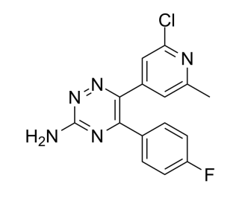
Formula: C₁₅H₁₁ClFN₅
IUPAC : 6-(2-chloro-6-methylpyridin-4-yl)-5-(4-fluorophenyl)-1,2,4-triazin-3-amine
Storage/Stability :
- 3 years , -20°C, powder
- 2 years, -80°C, in solvent
HPLC: 99.17% purity
Solubility:
DMSO - 63 mg/mL (199.53 mM)
Water solubility - < 1 mg/mL
Ethanol - 4 mg/mL (12.66 mM)

Qualification and Identification thresholds :

100 mg/day (MDD) :
1 mg/day
Qualification Threshold 100 mg/day dose (%) : = ----------------- * 100 = 1 %
100 mg/day
Identification Threshold is 1 %

200 mg/day (MDD) :
1 mg/day
Qualification Threshold 200 mg/day dose (%) : = ----------------- * 100 = 0.5 %
200 mg/day
Identification Threshold is 0.1 %

1000 mg/day (MDD) :
1 mg/day
Qualification Threshold 1000 mg/day dose (%) : = ----------------- * 100 = 0.1 %
1000 mg/day
Identification Threshold is 0.05 %

1500 mg/day (MDD) :
1 mg/day
Qualification Threshold 1000 mg/day dose (%) : = ----------------- * 100 = 0.06 %
1500 mg/day
Identification Threshold is 0.05 %

MDD | Qualification threshold (%) | Identification threshold (%)
100 mg/day | 1 | 1
200 mg/day | 0.5 | 0.1
1000 mg/day | 0.1 | 0.05
1500 mg/day | 0.16 | 0.05
Metals and Impurities :
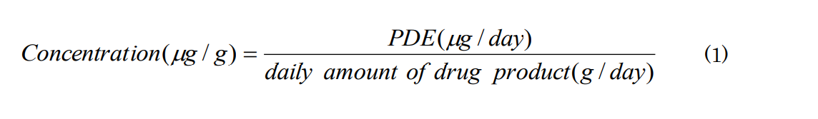
Palladium (ppm) :

PDE = 100 ug/day
Dose = 100 mg/day
Concentration - maximum allowable limit = 100 ug/ 0.1g = 1000 ppm

Iridium(ppm):

PDE = 100 ug/day
Dose = 100 mg/day
Concentration - maximum allowable limit = 100 ug/ 0.1g = 1000 ppm

Pyridine:

PDE = 2 mg/day
Dose = 100 mg/day
Concentration - maximum allowable limit = 2 mg/day / 100 mg/day = 2%

Impurity | PDE | Dose | Maximum allowable limit
Palladium | 100 ug/day | 100 mg/day | 1000 ppm
Iridium | 100 ug/day | 100 mg/day | 1000 ppm
Pyridine | 2 mg/day | 100 mg/day | 2%

Solvents:

Methanol:

PDE = 30 mg/day
Dose = 100 mg/day
Concentration - maximum allowable limit = 30 mg/day / 100 mg/day = 0.3%

Tetrahydrofuran

PDE = 7.2 mg/day
Dose = 100 mg/day
Maximum allowable limit = 7.2 mg/day / 100 mg/day * 100 = 7.2 %

DMSO - d6:

PDE = 500 ppm (5 mg/day)
Dose = 100 mg/day
Maximum allowable limit = 5 mg/day / 100 mg/day * 100 = 5 %

Individual unspecified impurities

Qualification threshold for 100 mg/day dose (%) = 1 mg/day / 100 mg/day * 100 = 1 %

Solvent | PDE | Dose | Maximum allowable limit
Methanol | 30 mg/day | 100 mg/day | 0.3 %
Tetrahydrofuran | 7.2 mg/day | 100 mg/day | 7.2%
DMSO-d6 | 5 mg/day | 100 mg/day | 5 %
Batch Data (100 mg/day):

For Metals
Batch # | Appearance | Color | Assay(%) | Identify by HPLC | Palladium  (ppm) | Iridium (ppm) | Tantalum (ppm)  < 1 | Water (%)
AZD4635_A  (Toxicology batch) | Powder | White | 99 | Complies | 98 | 29 | 0.7 | 0.5
AZD4635_B | Powder | White | 96 | Complies | 96 | 66 | 0.5 | 0.3
AZD4635_C | Powder | White | 97 | Complies | 67 | 69 | 0.4 | 0.4
AZD4635_D | Powder | Off-white | 94 | Complies | 60 | 69 | 0.3 | 0.2
AZD4635_E | Powder | White | 96 | Complies | 16 | 65 | 0.6 | 0.7

For Impurities
Batch # | Individual unspecified Impurities (%) | Total Impurities (%) | Tetrahydrofuran (%) | Pyridine (%) | Methanol (%) | Total volatiles (%)
AZD4635_A  (Toxicology batch) | 0.19 | 0.27 | 0.8 | 0.5 | 0.03 | 1.79
AZD4635_B | 0.17 | 0.25 | 0.3 | 0.6 | 0.06 | 1.38
AZD4635_C | 0.14 | 0.26 | 0.4 | 0.4 | 0.17 | 1.37
AZD4635_D | 0.15 | 0.25 | 0.5 | 0.5 | 0.08 | 1.48
AZD4635_E | 0.10 | 0.24 | 0.3 | 0.2 | 0.15 | 0.99

Drug Substance Specification (AZD4635) :

Test | Acceptance Criteria | Results
Appearance | Powder | Powder
Color | Off-White - White | White
Identity (HPLC) | Must be comparable to a standard spectrum run under same conditions | Complies
Assay (LC) | Quantitative NMR (QNMR) : Consistent with structure  NLT 94% and NGT 99% | > 98 %
Palladium (ICP-MS) | NGT 100 ppm | 16 - 98 ppm
Iridium | NGT 100 ppm | 29 - 69 ppm
Tantalum | NGT 1 % | 0.3 – 0.7 %
Water (KF) | NGT 1 % | 0.2 – 0.7 %
Individual unspecified impurities | NGT 0.2% | 0.10 – 0.19%
Total impurities | NGT 1.0% | 0.24 – 0.27
Methanol | NGT 1.0% | 0.03 – 0.17
Pyridine | NGT 1.0% | 0.2 – 0.6 %
Total Volatiles (GC) | NGT 2.0% | 0.99 – 1.79%
Tetrahydrofuran | NGT 1.0% | 0.3 – 0.8%
Particle Size | Report Results | 5µm

Justification for Limits Chosen :

- In the Synthesis it was mentioned that crystallization was done control palladium and iridium to within the specification 100 ppm. That I choose acceptance criteria as 100 PPM and limits from the batch as 16-98 ppm for palladium , 29-69 ppm for iridium.
- Color range is from the experimental methods conducted ranging from off-white power to white power.
- Particle size chosen based since 5 µm filter was used in crystallizing vessel.

