Please complete your coursework within a Microsoft Word document and submit your completed exercise through the Turnitin submission point found in the CHEM1110 Moodle shell by 17:00 on the 25/03/2022.

Exercise
You are working within the pharmaceutical industry, and you have been assigned a kinase to develop an inhibitor for. Your team has already found a compound that can moderate the activity of the kinase of interest (for your kinase/compound paring, please look for your name in the Excel spreadsheet in the CHEM1110 Moodle shell - where you found this guidance).
- Using this information, use AutoDockTools and Autodock Vina to dock your compound with the kinase of interest. Your report should include

(a) A brief explanation of how you determine the search area for the docking, accompanied by a suitable picture to show where the search box is located with respect to the kinase in your docking.

[Tips: To help you determine where the search area should be for the docking, you can go to the protein data bank, and search the PDB code of the kinase you are given. You will see a web page similar to the picture below, which contains information to describe your kinase target.

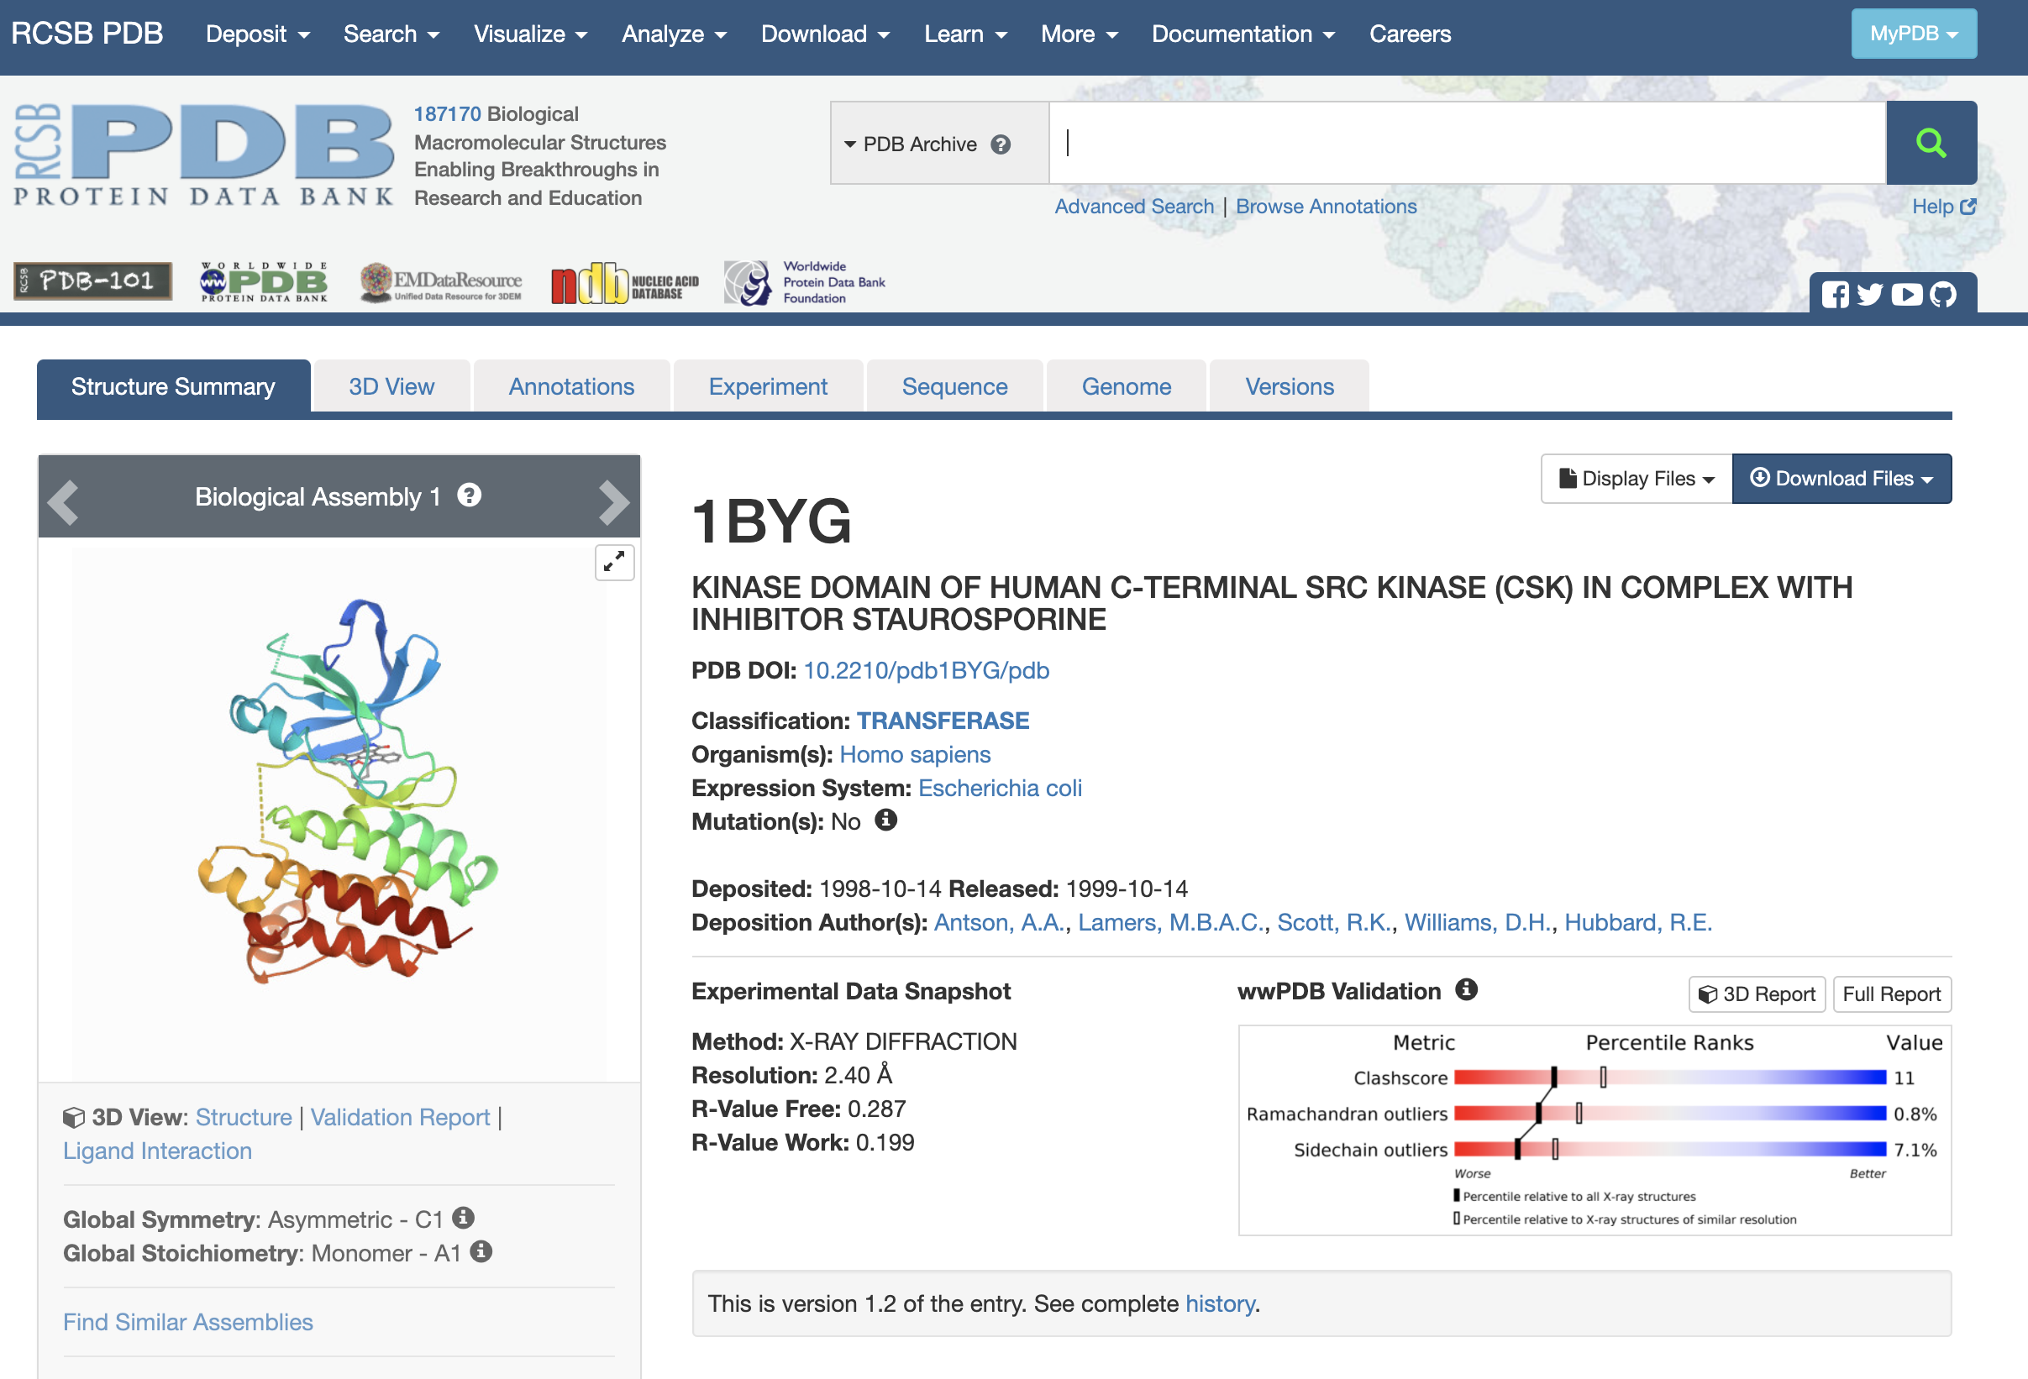

You can click “Ligand Interaction” which will bring you into a new page displaying where and how a drug molecule interacts with the kinase. You can use your mouse to rotate and zoom in/out to help you visualise the binding site.

Once you have a good understanding where the binding site should be, you need to adjust the dimensions, scaling factor and the centre of the search box in AutoDockTools based on this information. You need to make sure you define the search box correctly in your conf.txt file.

- Description of possible interactions between your compound and the kinase that you have identified after docking, accompanied by suitable picture(s) and labelling to highlight the interactions.

- A table to show the binding affinity of your compound and the kinase from docking
[20 marks]

- Based on the results from the molecular docking, and also using your knowledge of medicinal chemistry, make FIVE changes you would make to the molecule in order to probe SAR and increase binding efficiency. Your answer should be a maximum of ONE A4 page in length, should concisely describe why you are making those changes, and should include chemical drawings of your hit compound and subsequent analogues in order to visualise those changes.
[20 marks]

You will also be assessed on the overall presentation and clarity of your submission.
[10 marks]
[Total 50 marks]

