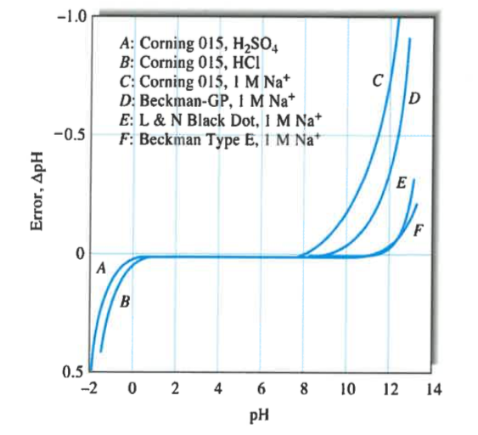
b) what is the origin of error at higher pHs?
c) Explain the sign of the high pH error?
d) what is the origin of low pH error?
e) Explain the sign of the low pH error?

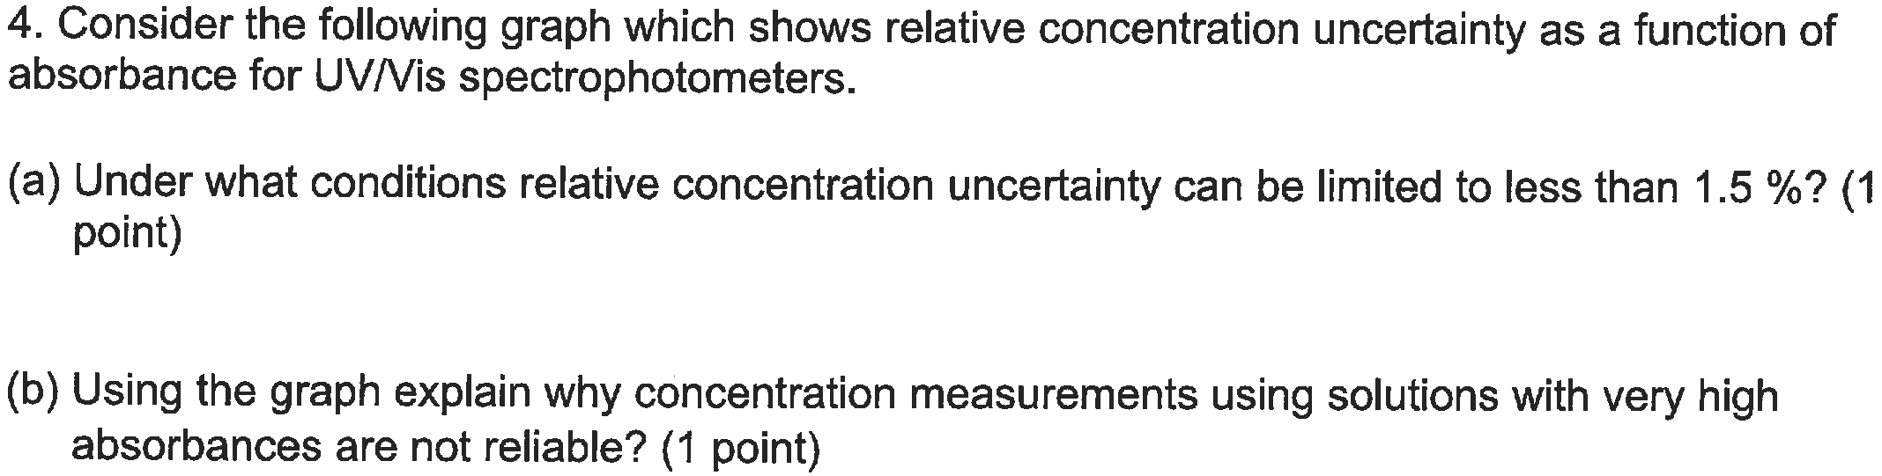

How concentration of such solutions can be measured more reliably?

Of a reference
